PROGRAM1:Web Configuration File

STEP 1:Go to file ,click new ,and choose website

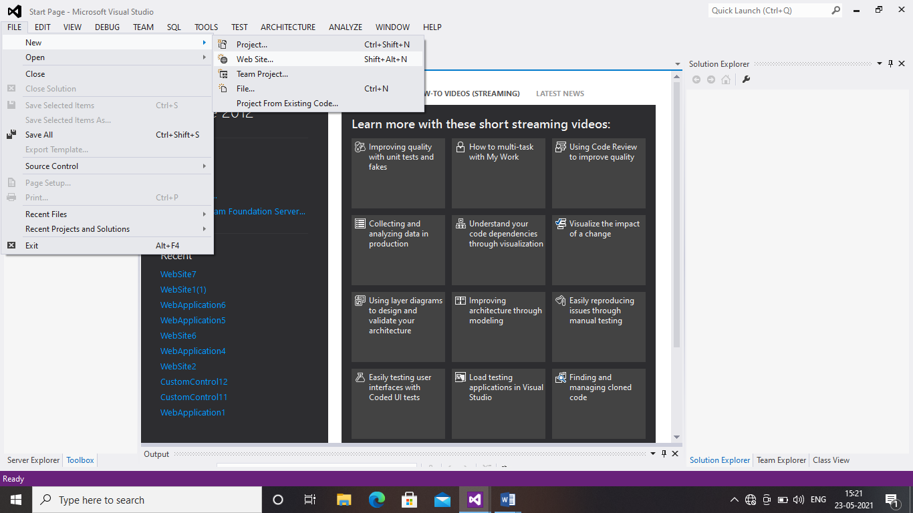

STEP 2:Choose empty web site

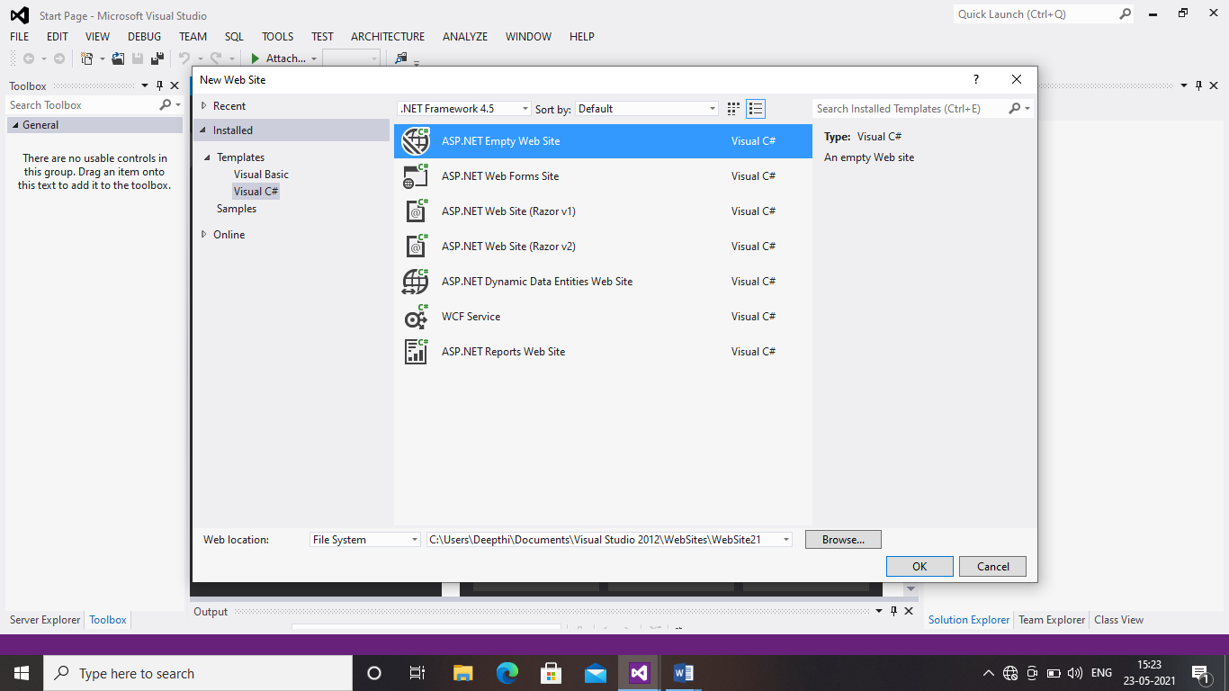

STEP 3:Right click on website and add new item

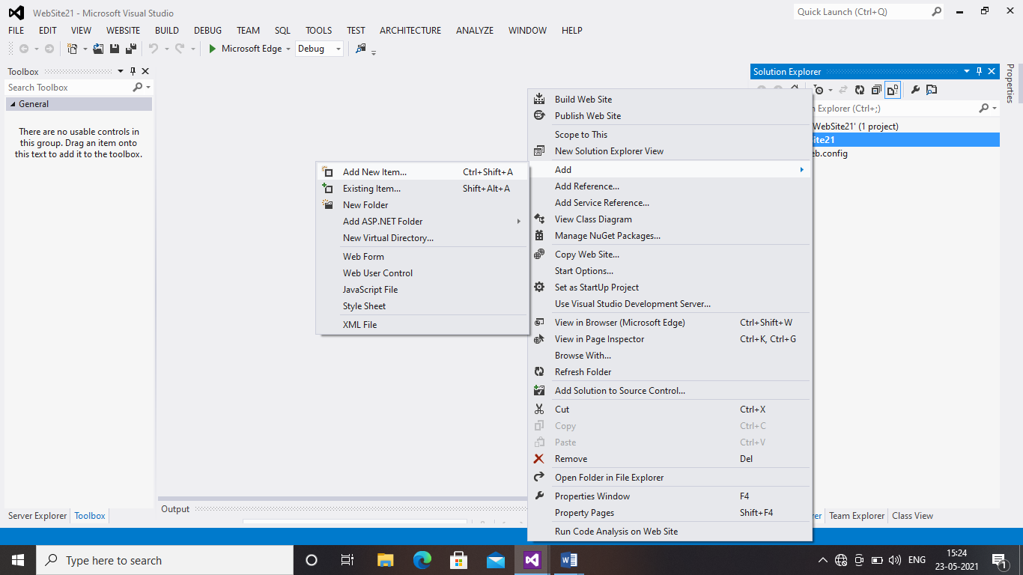

STEP 4:choose web form

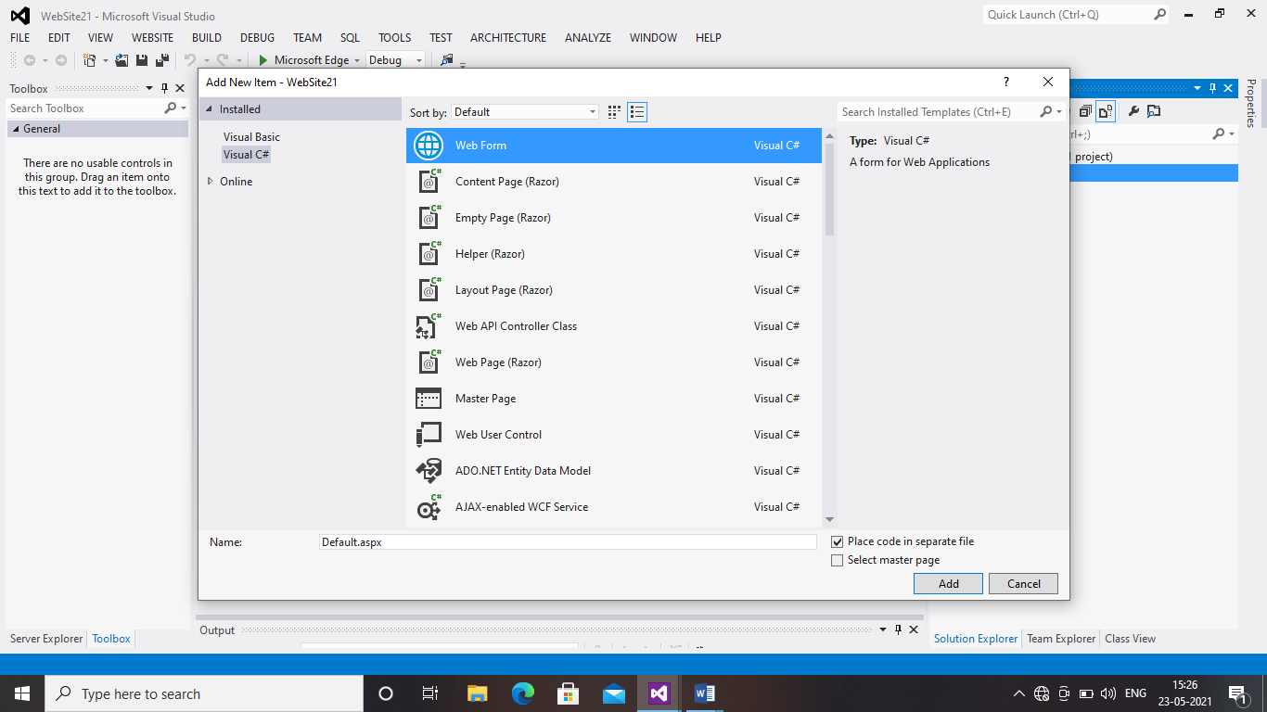

STEP 5:Type the code in the show below page

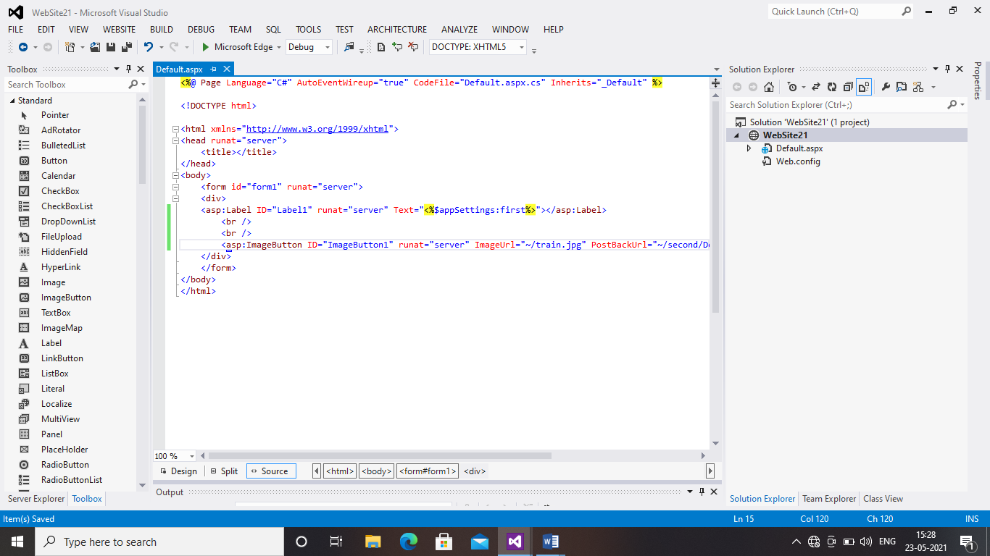

STEPS 6:Double click on web config file in solution explorer ad type the given coding

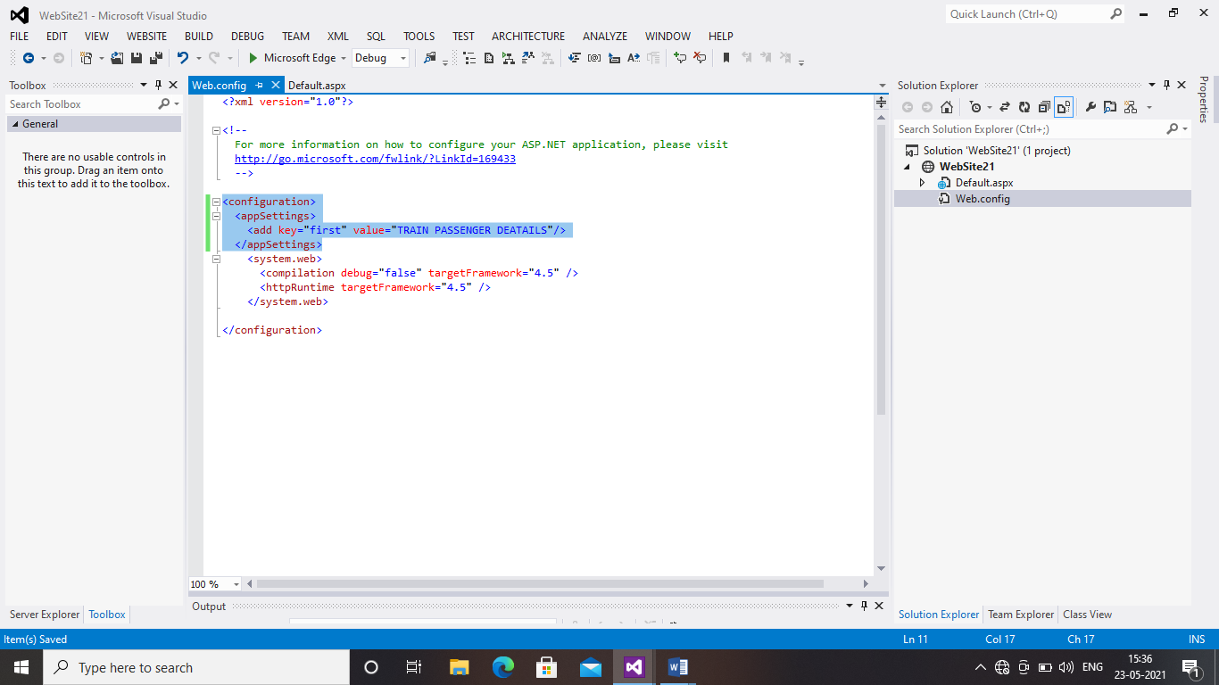

STEP 7:Right click on solution explorer and create the folder and give a name SECOND

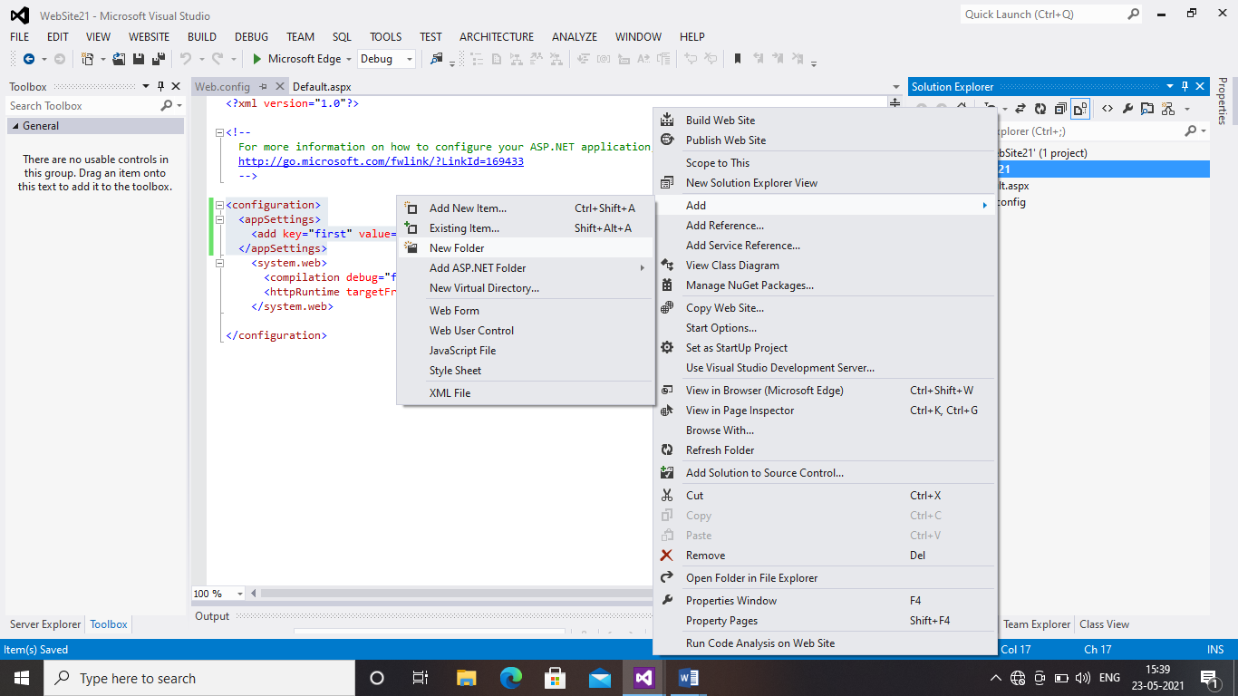

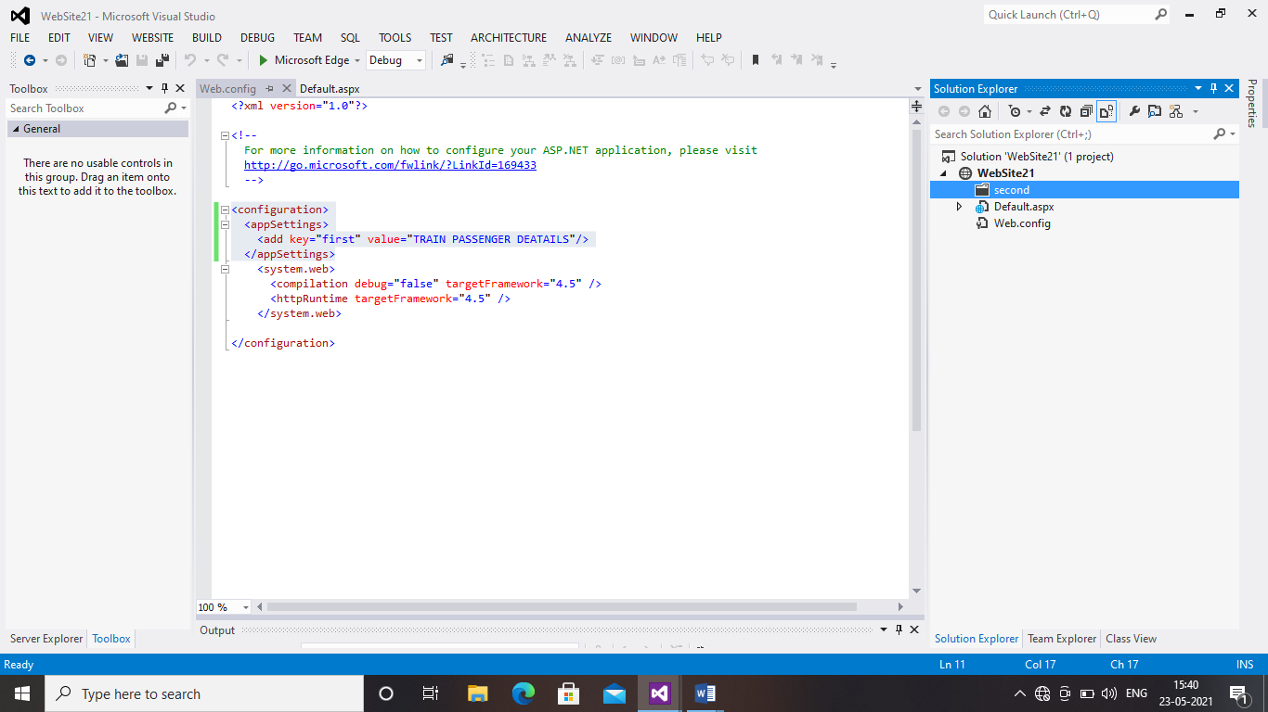

STEP 7:Right click on the second folder and add new item

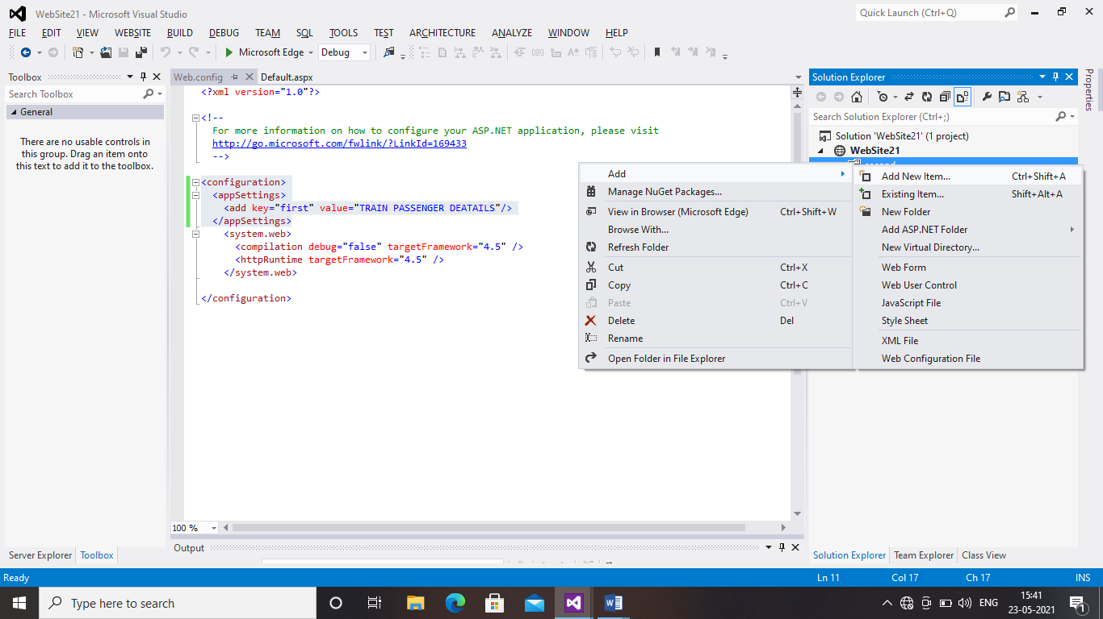

STEP 8:Choose Web Form

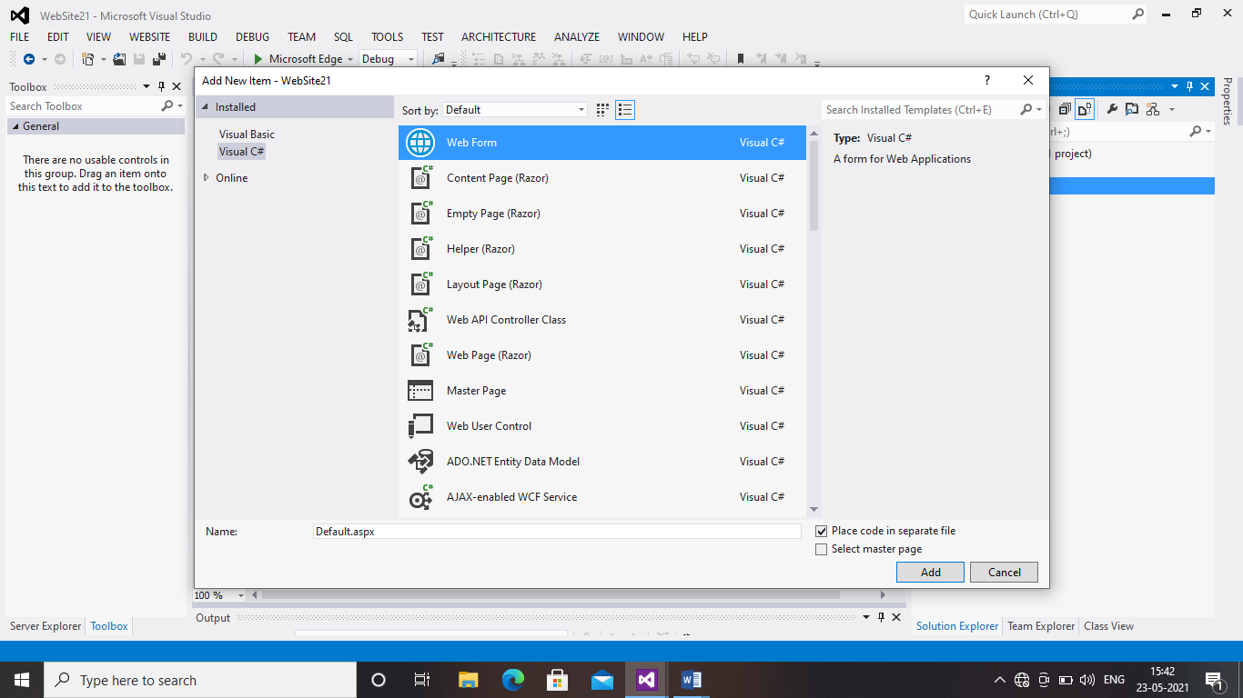

STEP 9:Right Click the second folder and Add the web configuration file

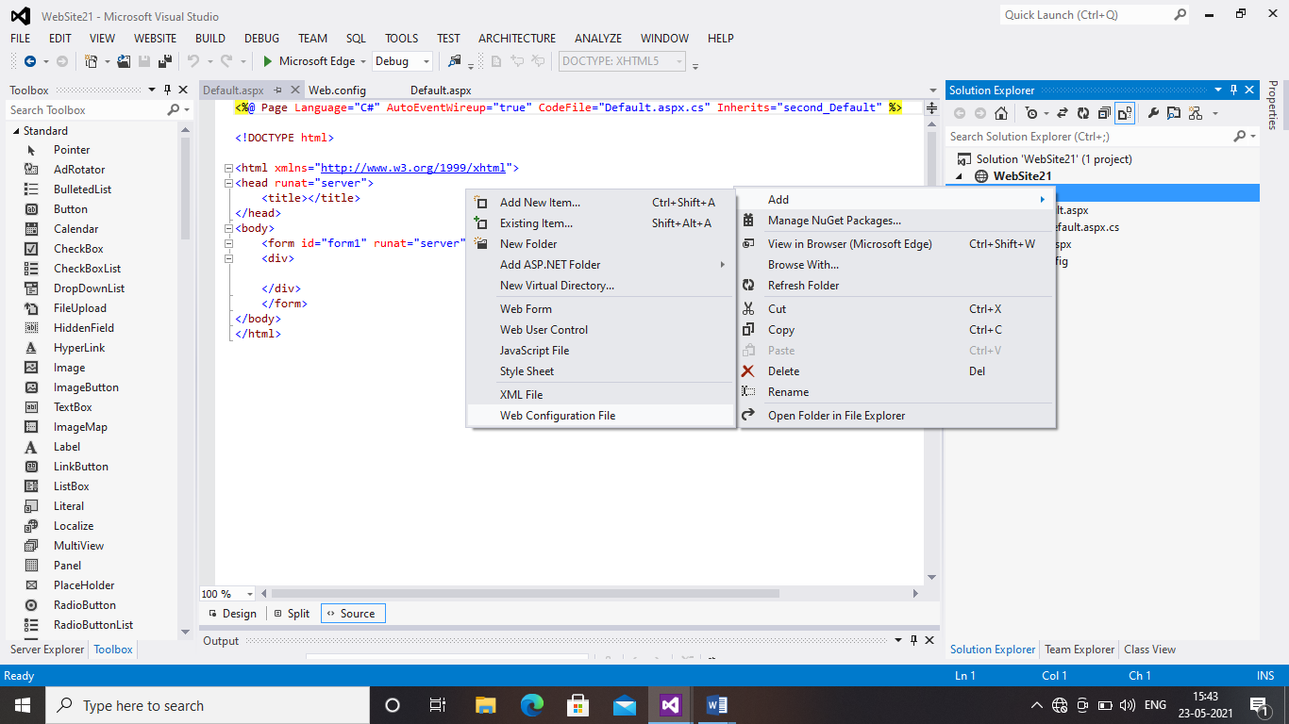

STEP 10:Type the given code in web config file which u have created in second folder

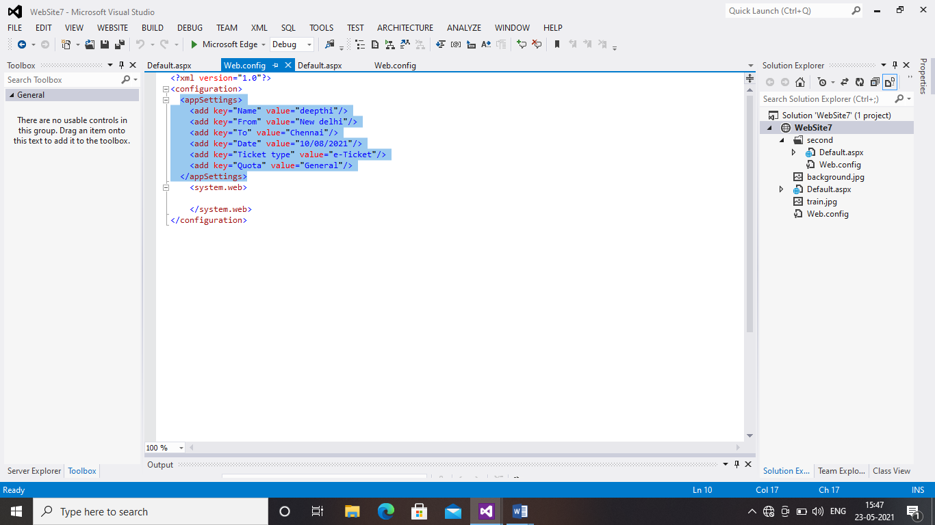

STEP 11:Type the given coding in default.aspx file which u have created in second folder

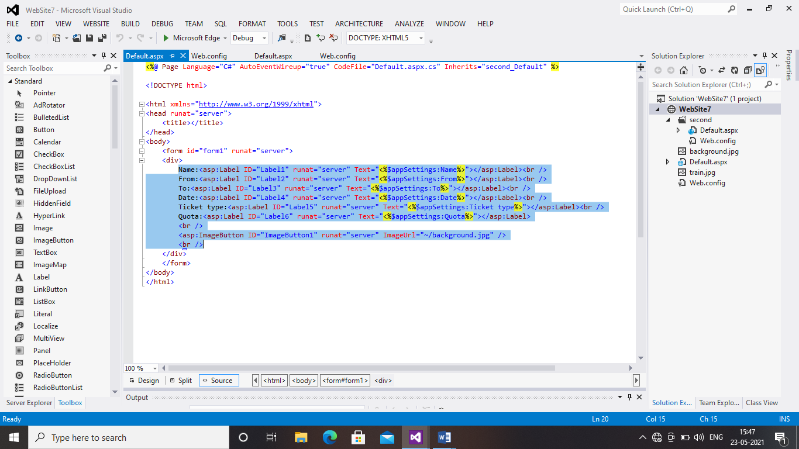

STEP 12:Right click on solution explorer and add the existing item and choose images which u have going to use in program

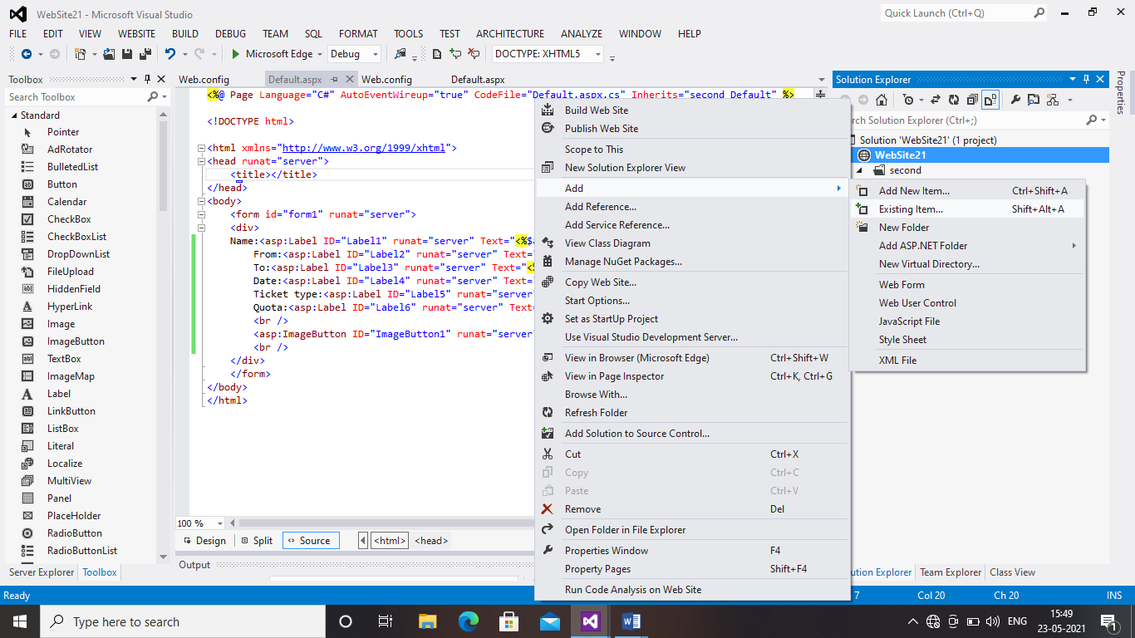

Here below I have added two images as BACKGROUND and TRAIN

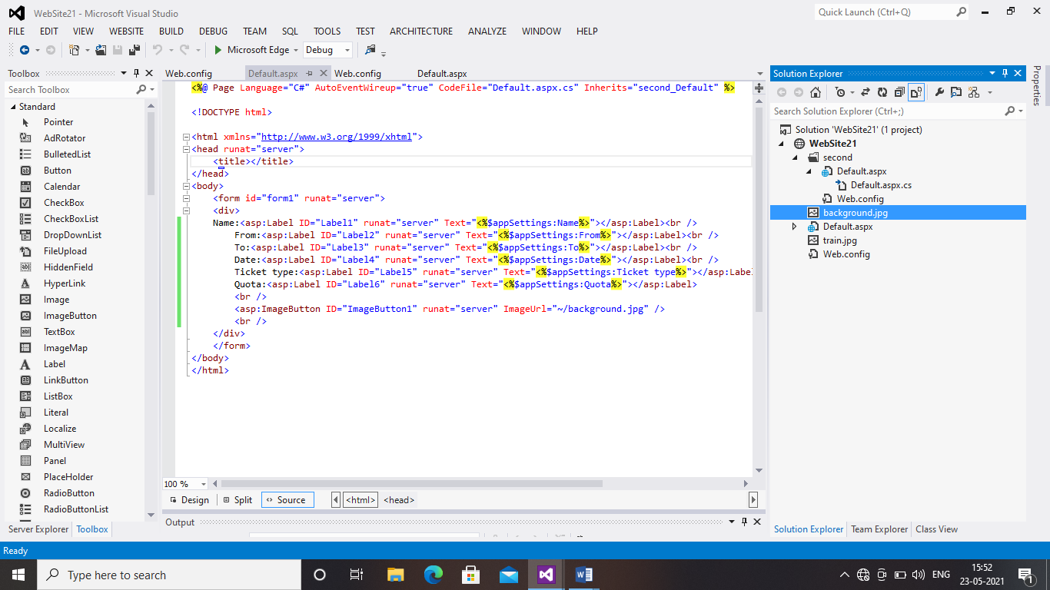

STEP 13:Save and Run the project

PROGRAM2:VIEW STATE

STEP 1:Go to file New and New Web Site

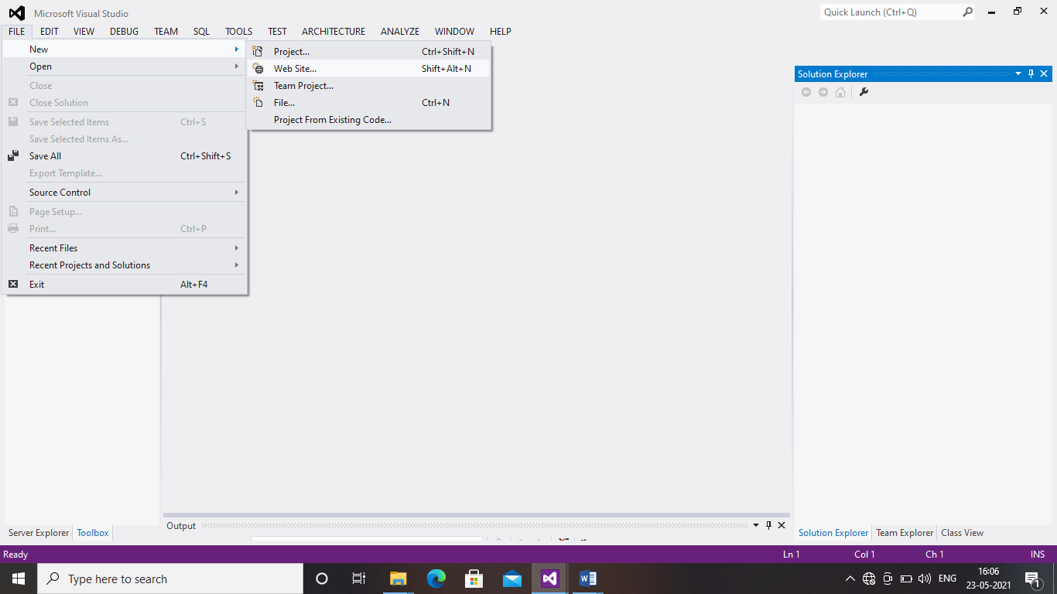

STEP 2: Choose empty web site

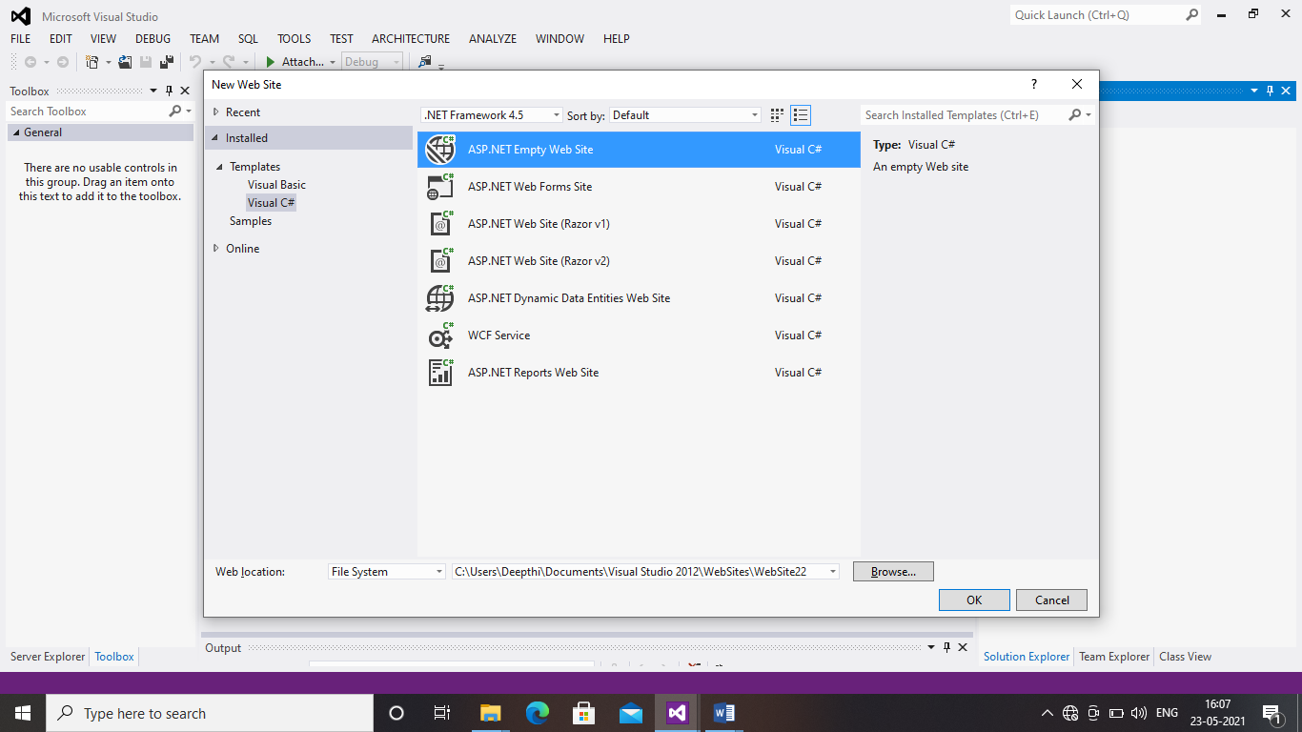

STEP 3:Right click on solution explore and add new item

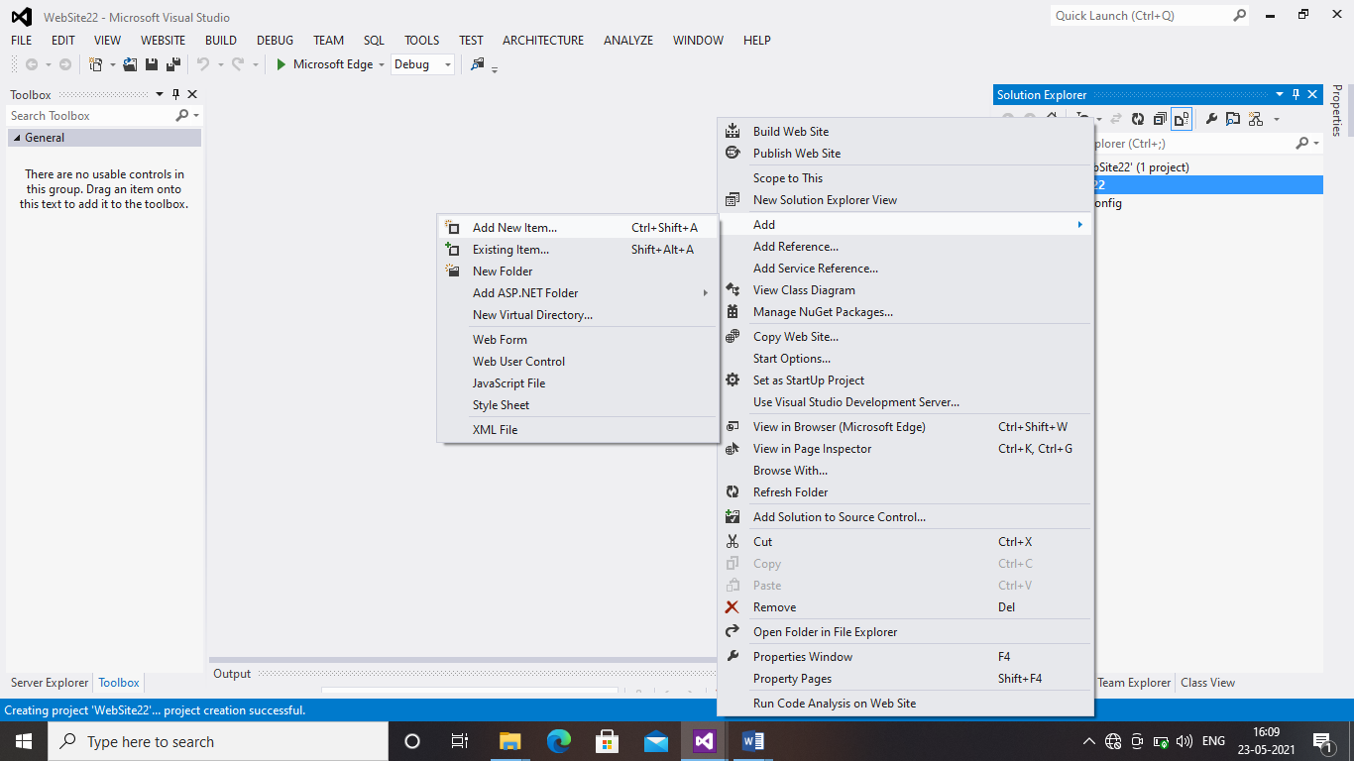

STEP 4:choose web form

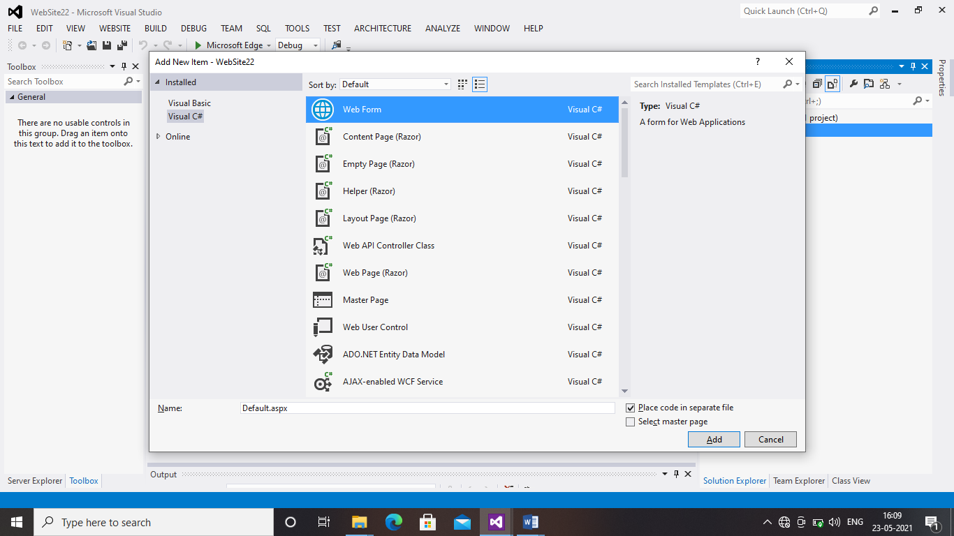

STEP 5:Type the given coding

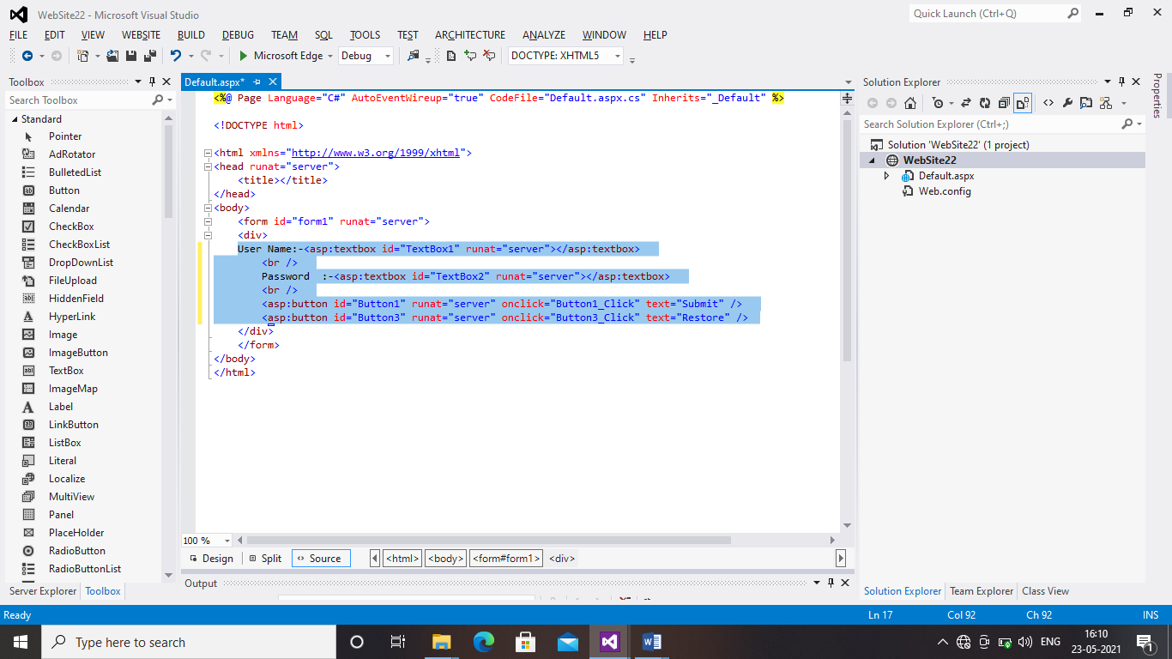

STEP 7:Save the project and Run

PROGRAM 3: HTML SERVER CONTROLS , CONTROL EVENTS, CONTAINER AND INPUT CONTROL CLASSES

STEP 1: Go to file ,click new ,and choose website

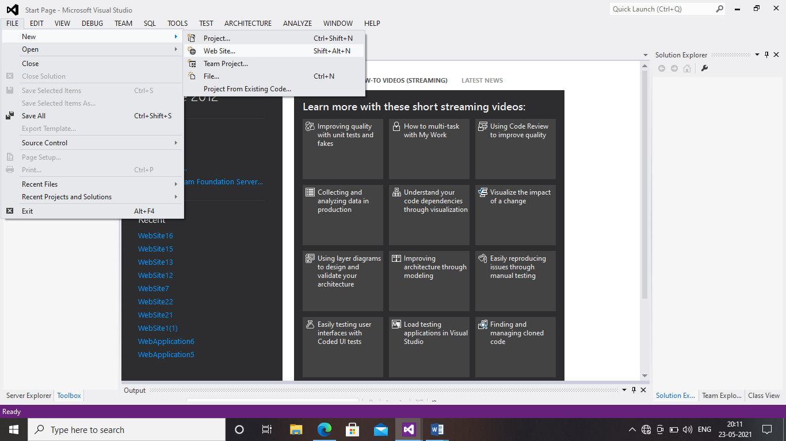

STEP 2: Choose empty web site

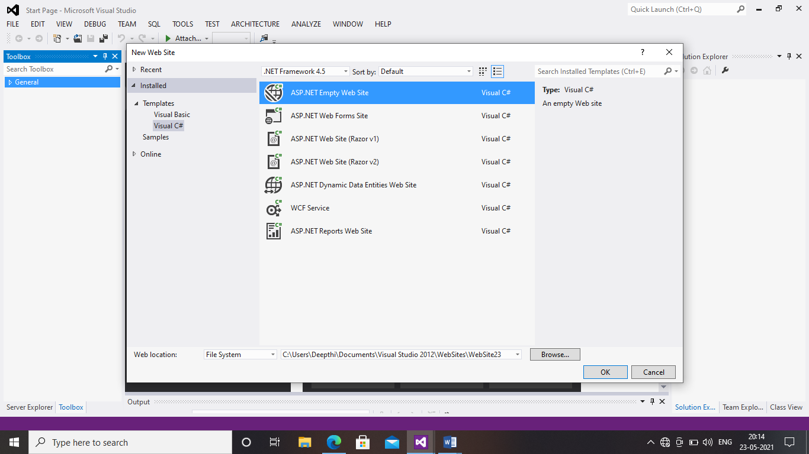

STEP 3: Right click on solution explore and add new item

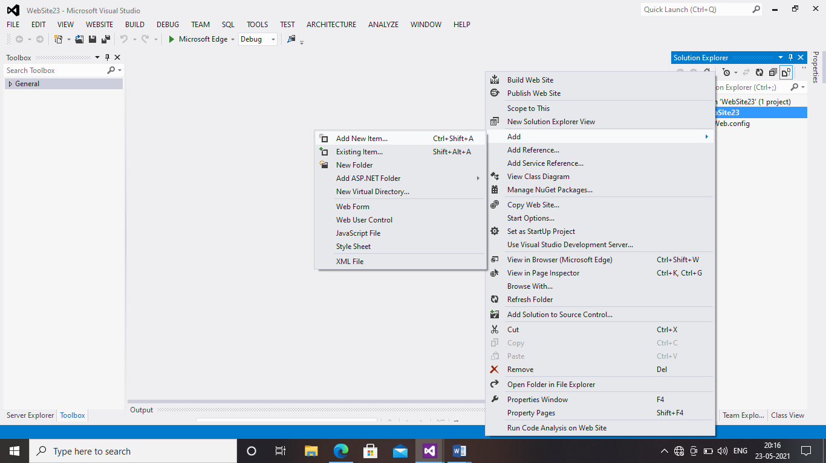

STEP 4: Choose Web Form

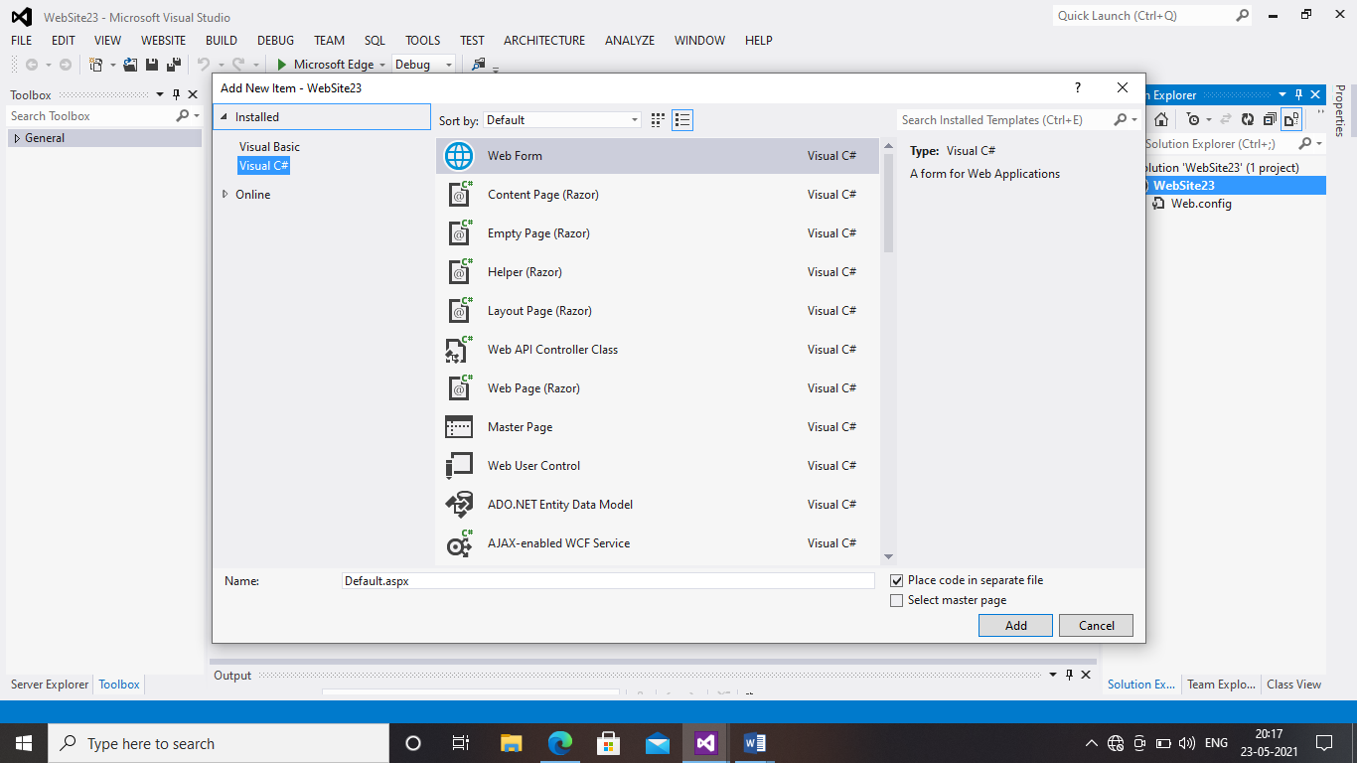

STEP 5:Type the given coding

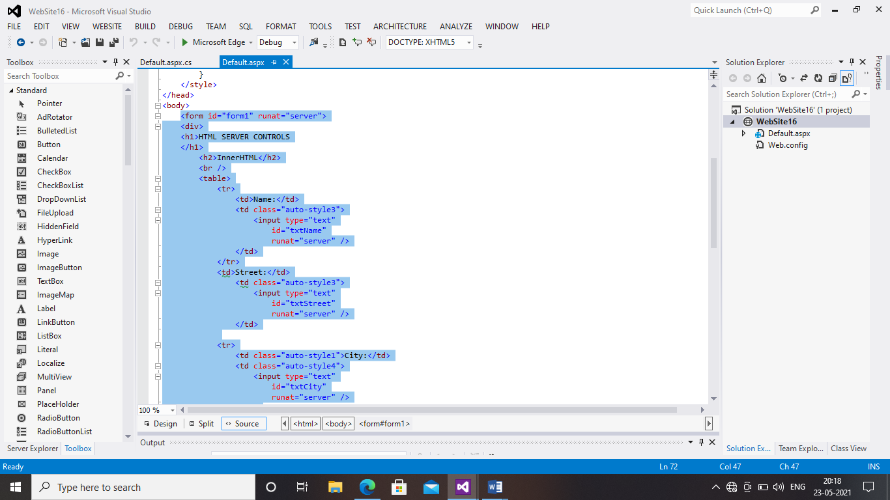

STEP 6:Save and Run the Project

PROGRAM 5: VALIDATION CONTROL

STEP 1: : Go to file ,click new ,and choose website

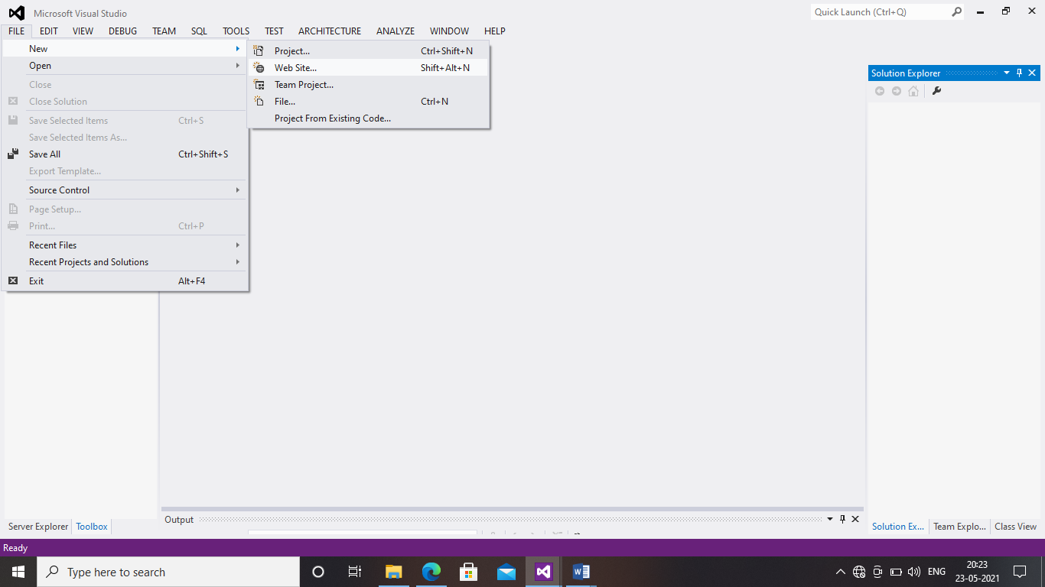

STEP 2: Choose empty web site



STEP 3: Right click on solution explore and add new item



STEP 4: Choose Web Form



STEP 5:Type the given coding

STEP 6:Save and Run the Project

PROGRAM 6:RICH CONTROLS

STEP 1:Go to the file, New, website

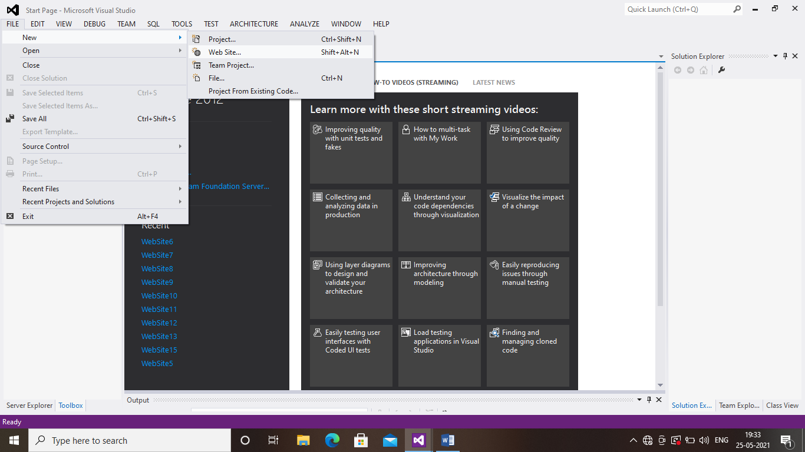

STEP 2:choose Empty website

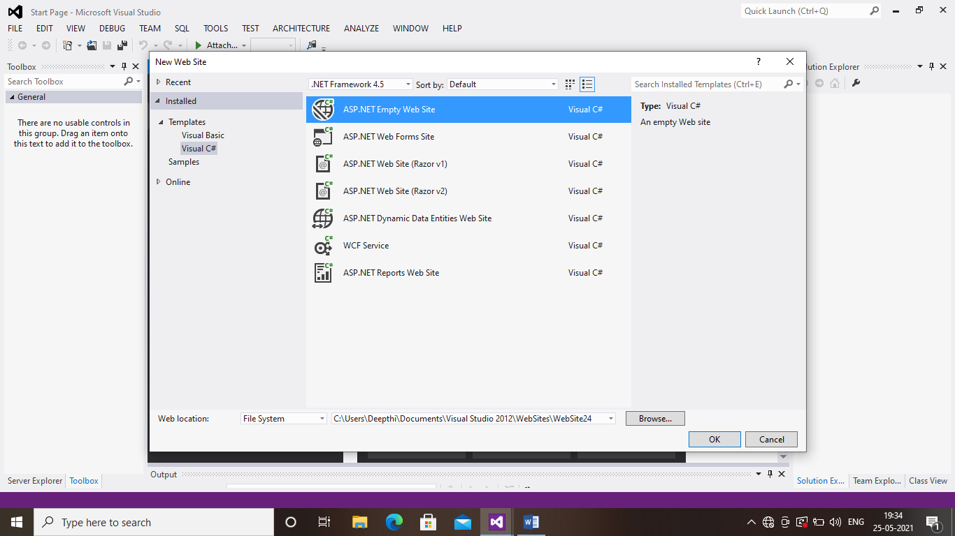

STEP 3:click solution explorer and add new item

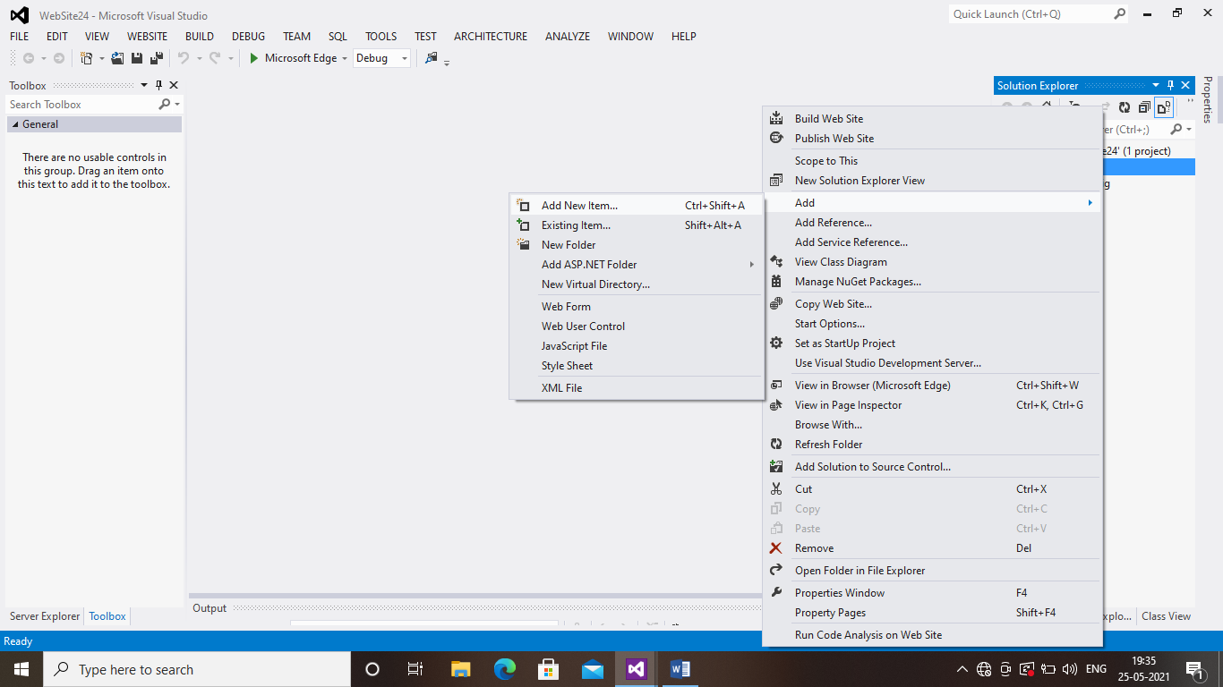

STEP 4:Choose web form

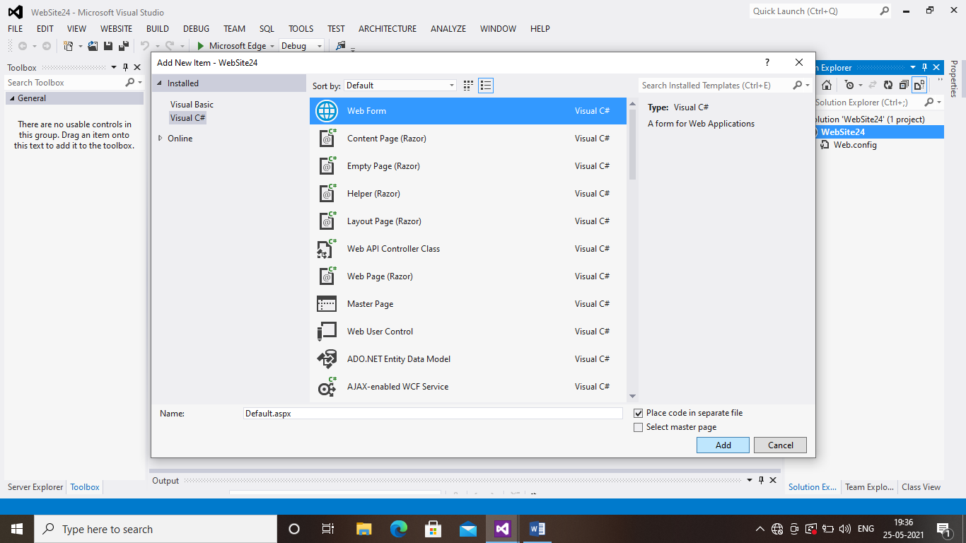

STEP 5:Again Right click the created web site and add new item

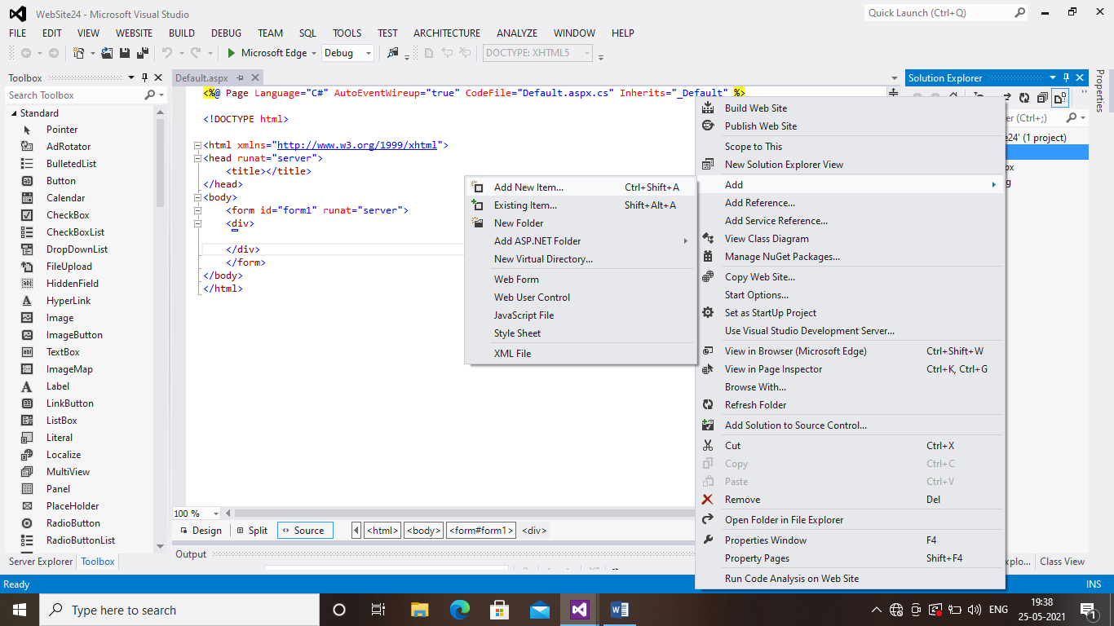

STEP 6:Choose XML file

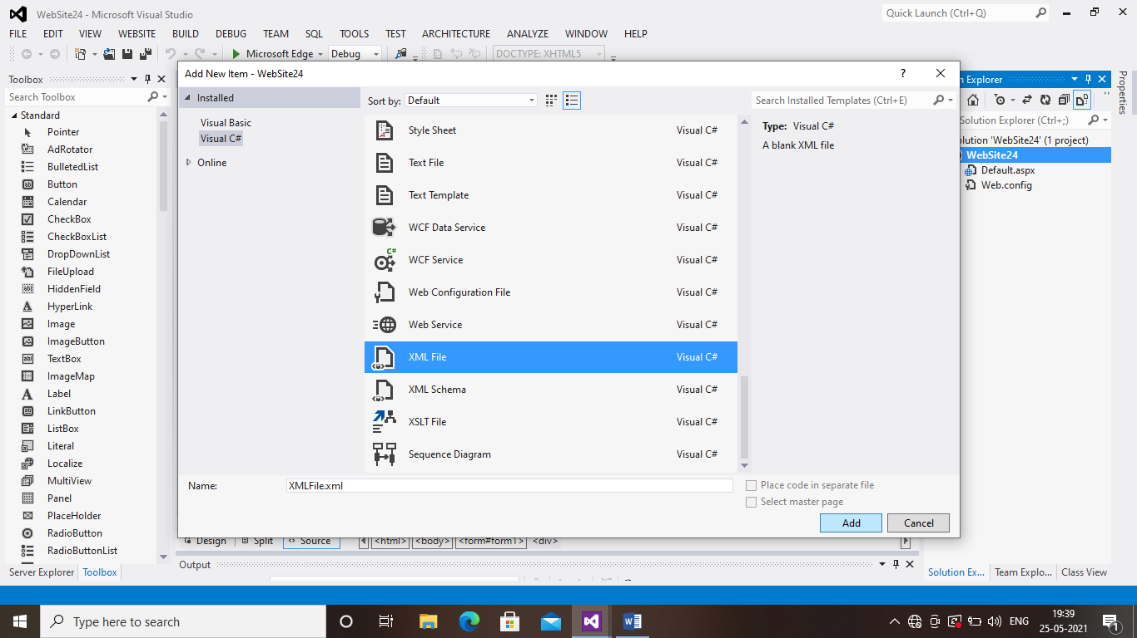

STEP 7:Type the given coding in xml file

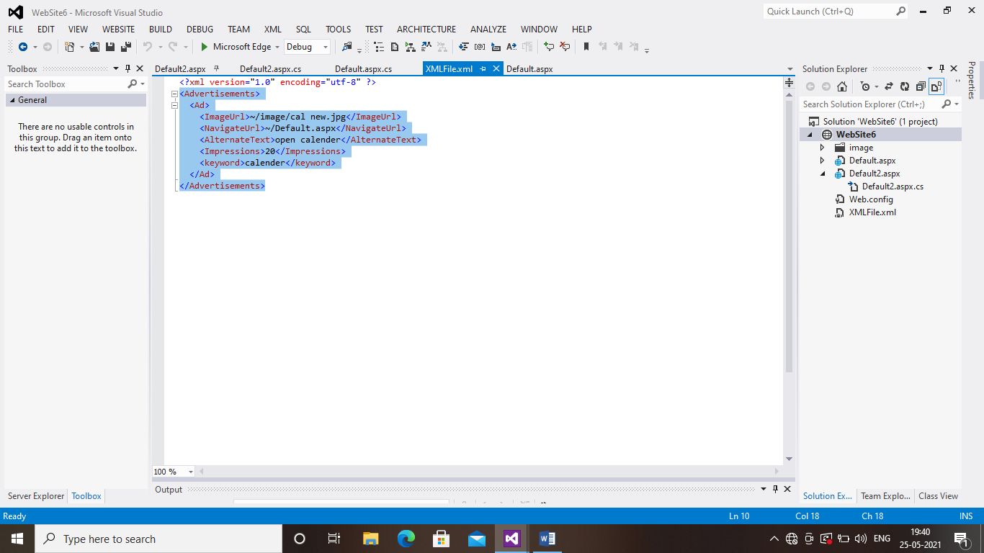

STEP 8:In this design page place Ad-rorator,script manager,and Update panel inside the update panel place one lable and timer control

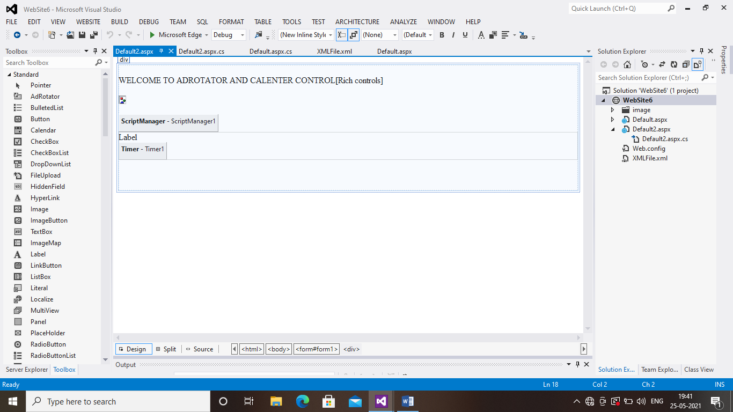

STEP 9:In deign page click Ad rotator and right click go to properties and choose advertisement file, and choose xml file click ok

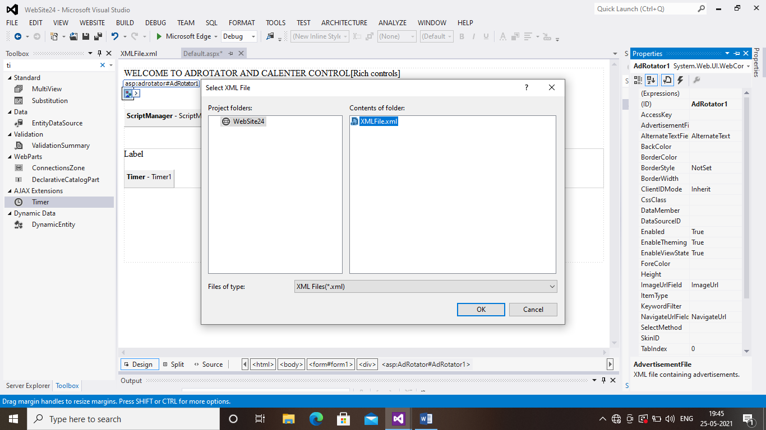

STEP 10:Right click the script manager and go to properties and choose script

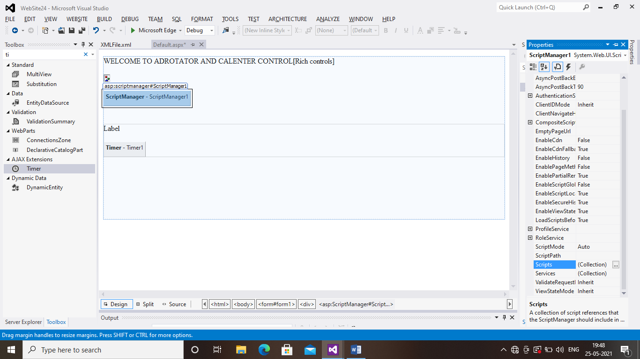

STEP 11:choose add and in script mode click Auto

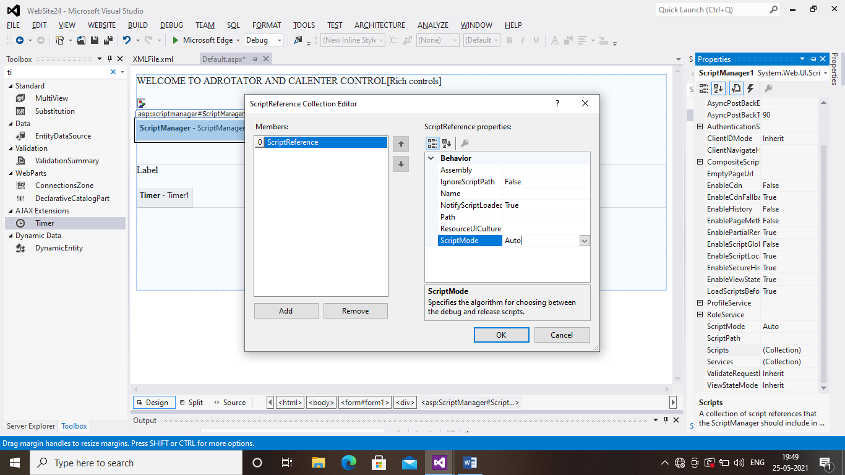

STEP 12:Right click the Timer and go to properties and change the Interval timing as 1000

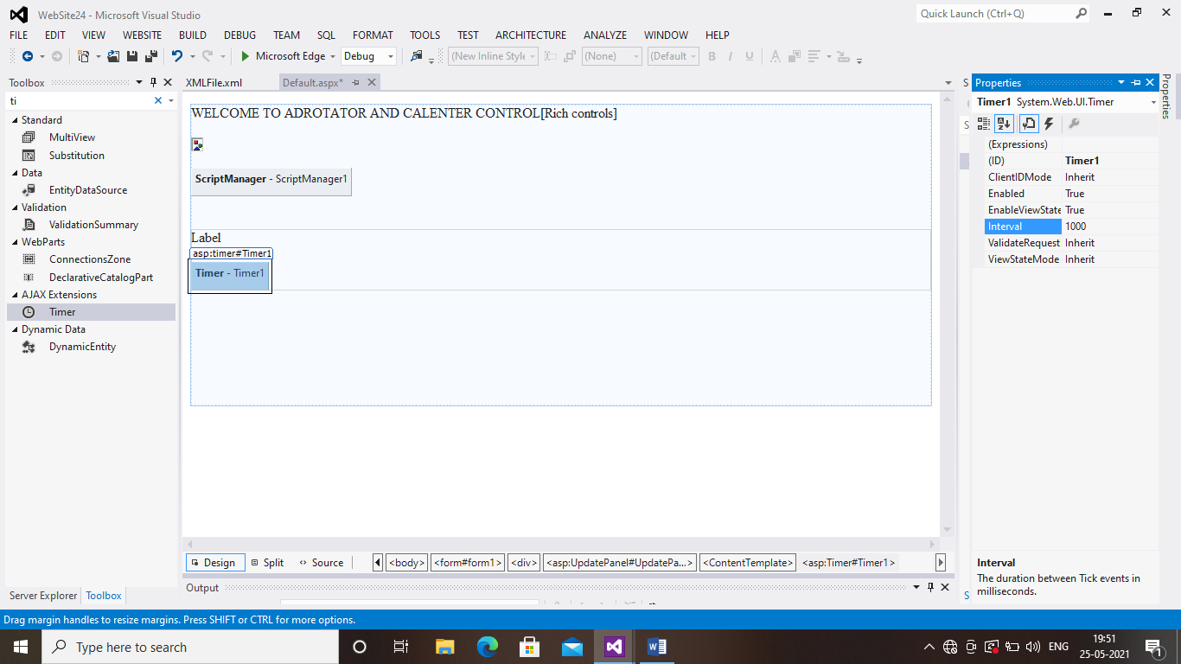

STEP 13:Go to events in the timer properties and double click the Tick

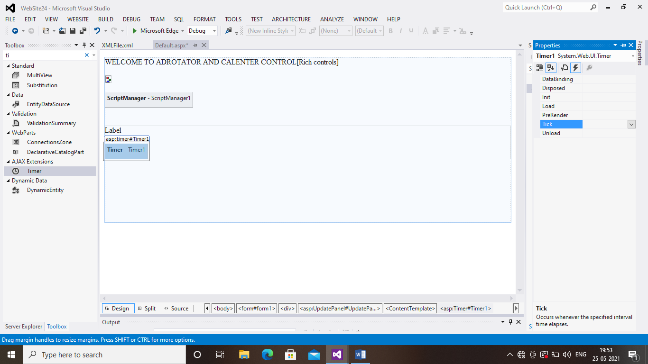

STEP 14:Right click the update panel and go to properties and choose trigger and add the Control Id and event name

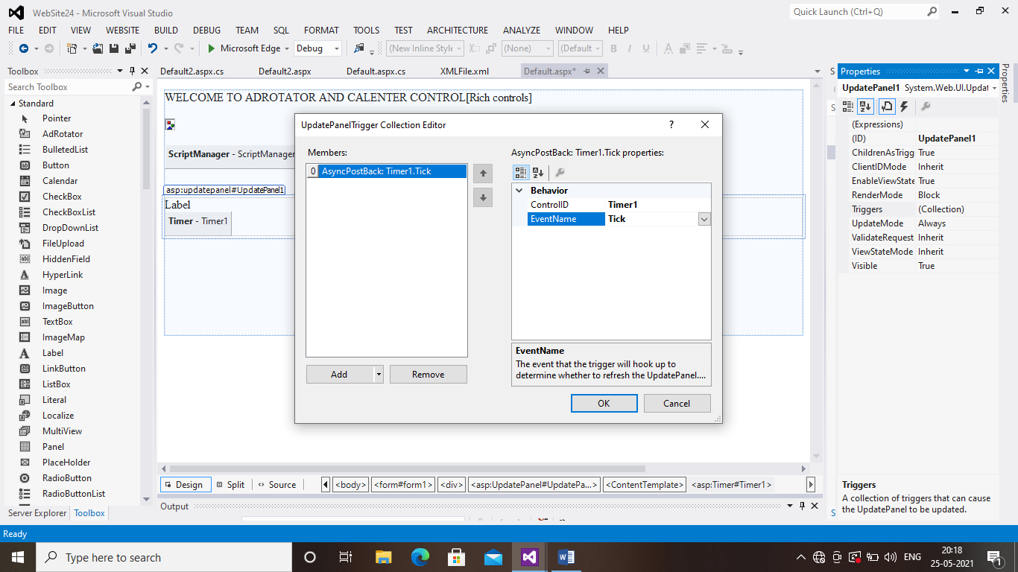

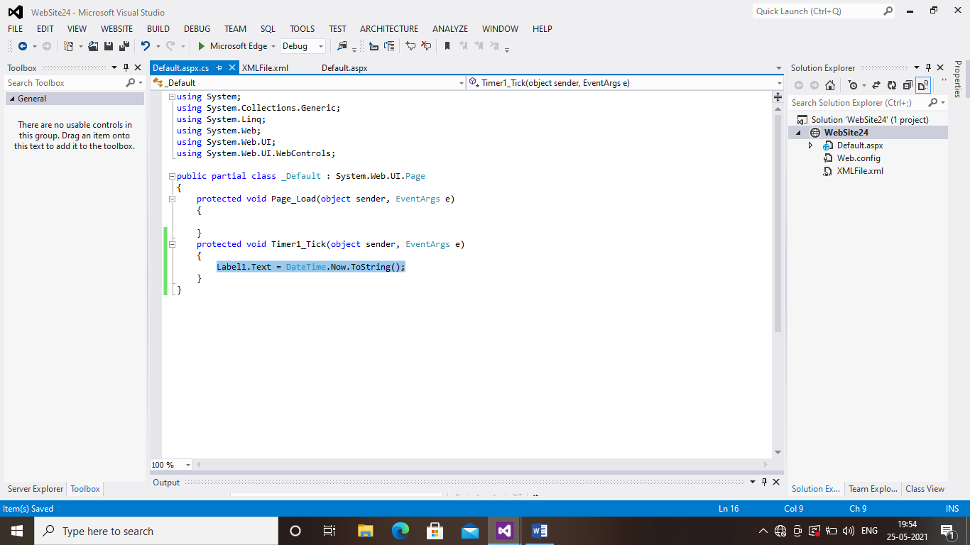

STEP 15:Right click on website in solution explorer and Add new Item

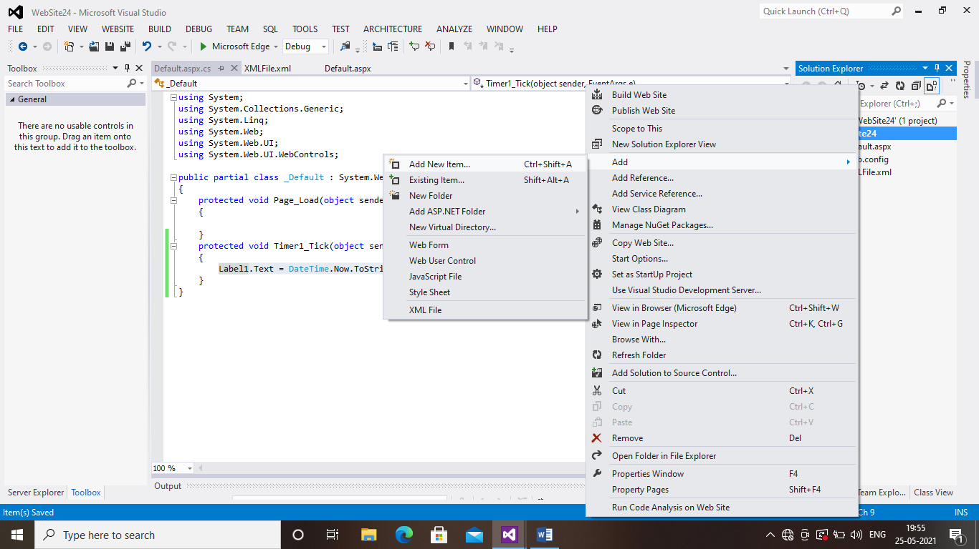

STEP 16:Choose web form

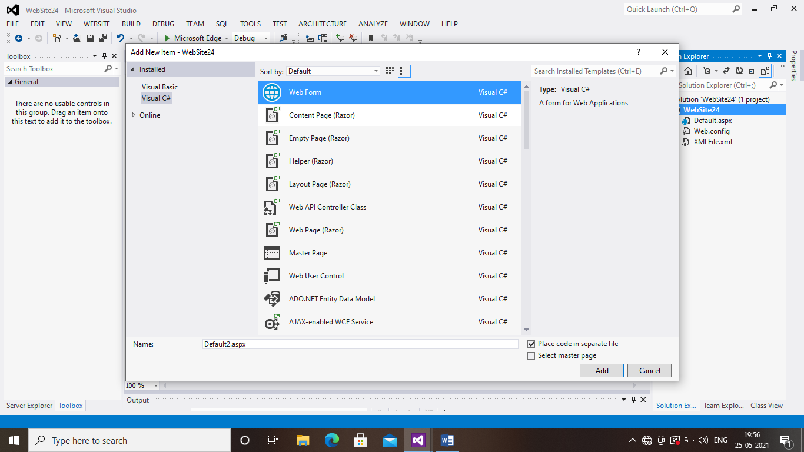

STEP 17:In design page place TextBox,Image Button,and Calender control

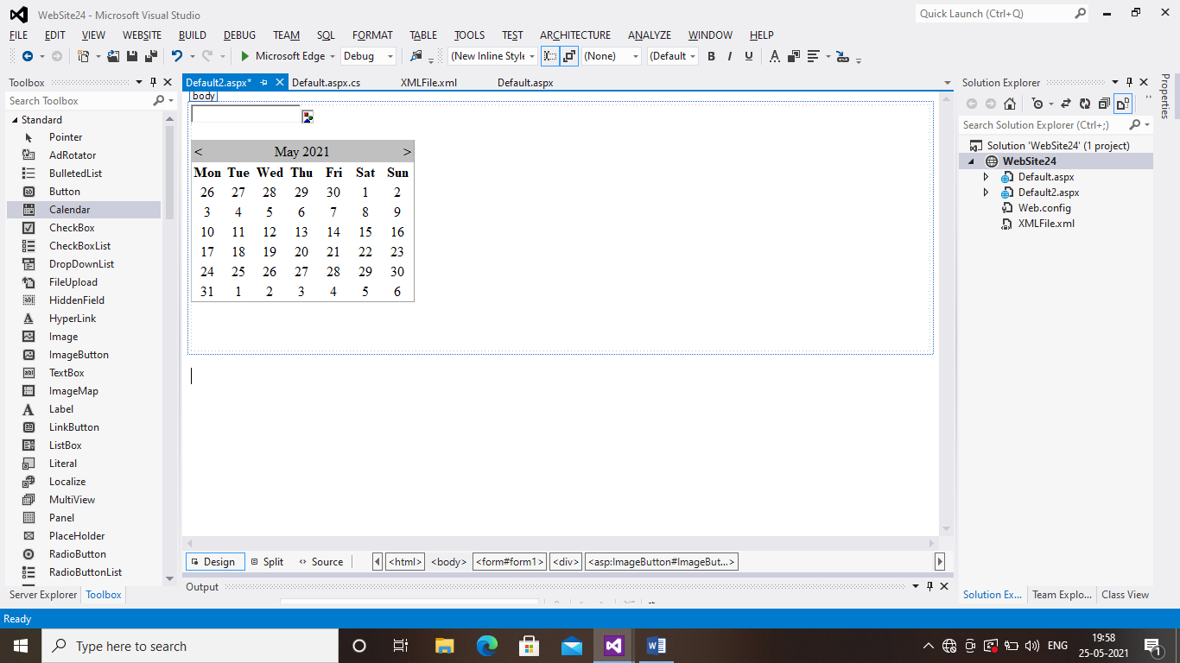

STEP 18:Right click the Web site in solution explorer and add ,Folder and give name as Image

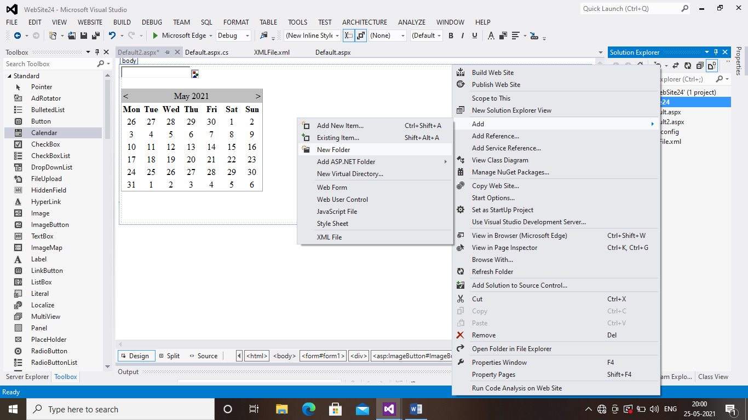

STEP 19:Right click the Image Folder and add existing Item ,and choose Images which ur going to use in program

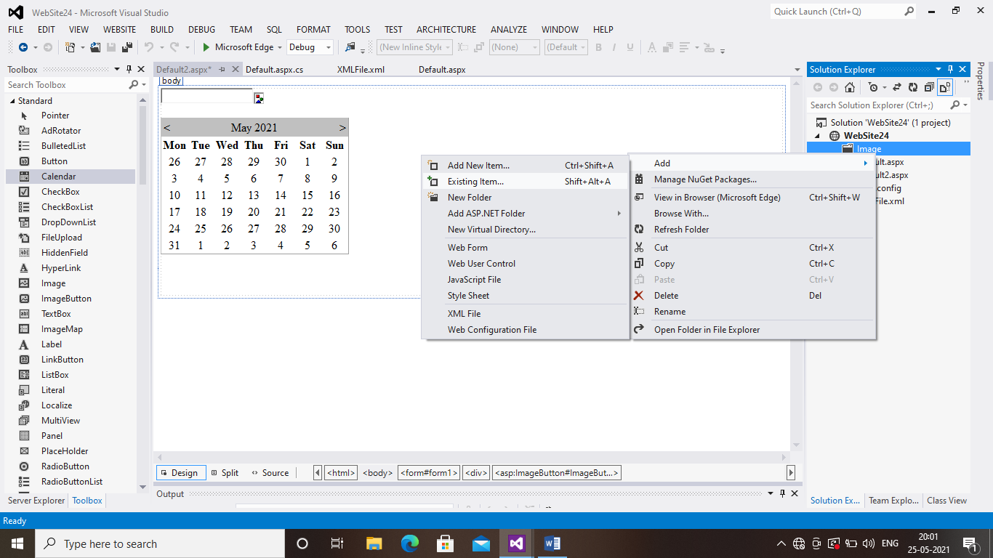

STEP 20:Right click the Image button and go to properties and select Image URL

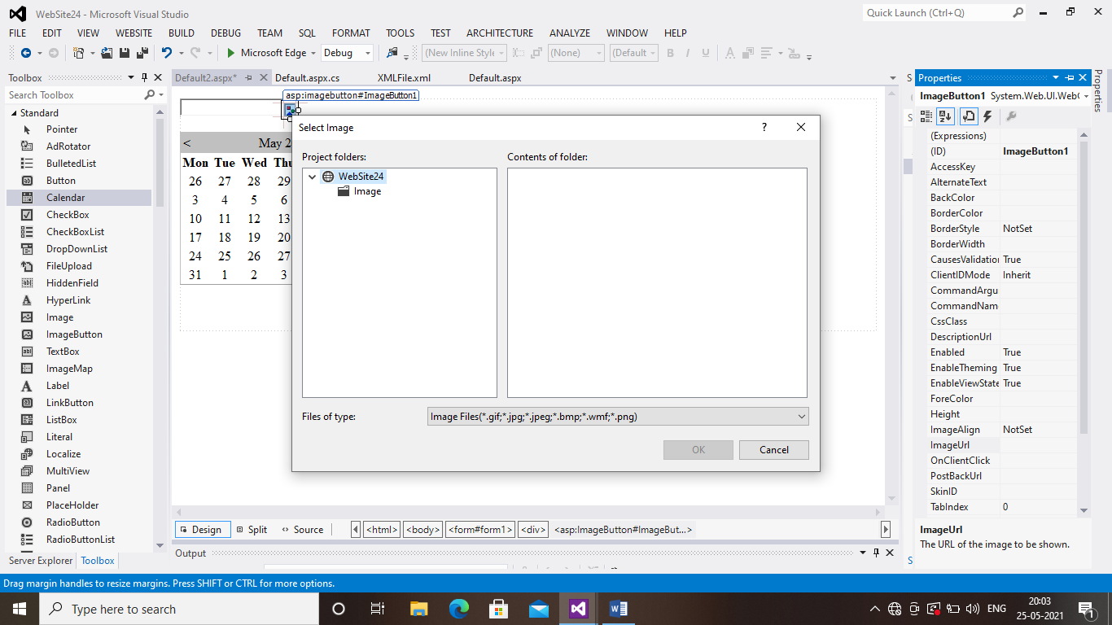

STEP 21:Click Image Choose images and click the image which u use

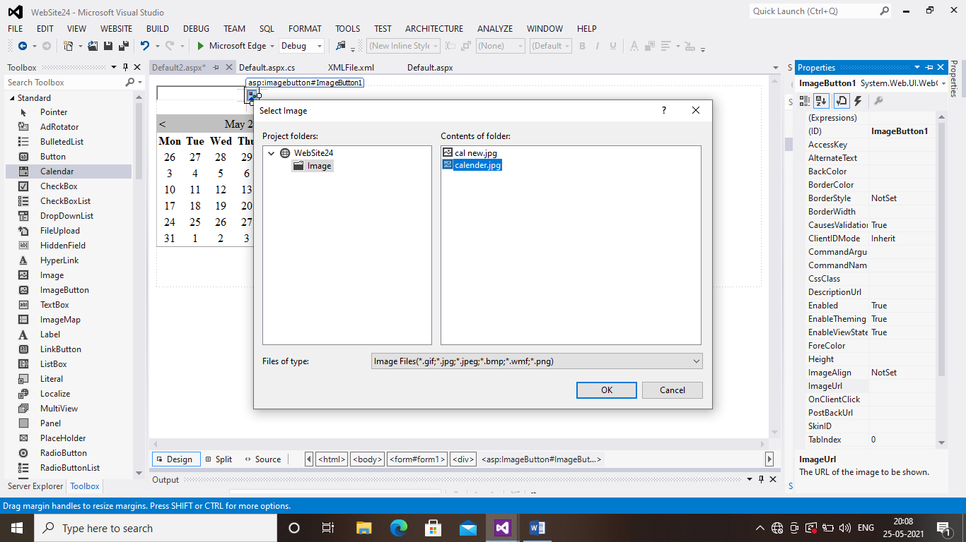

STEP 21:Double click the Image button and Calender and type the codings

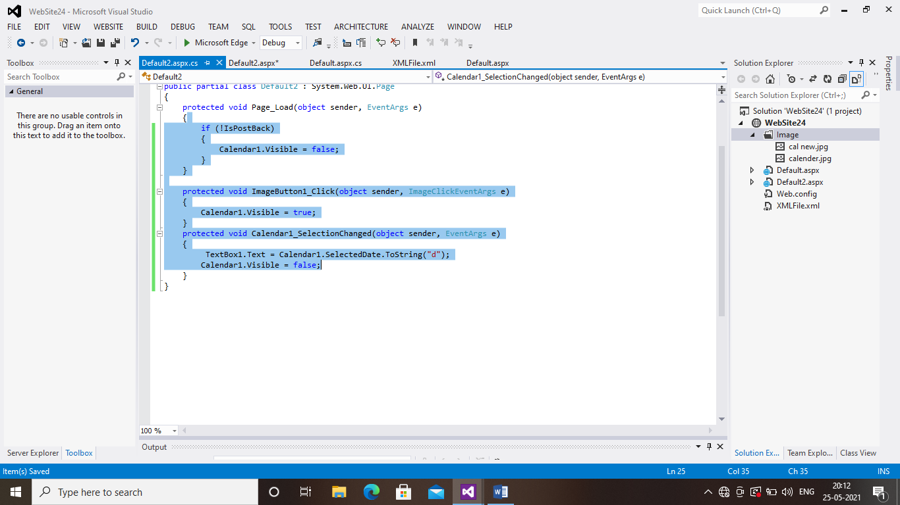

STEP 22:Save and run the project

PROGRAM 9:CUSTOM CONTROL

STEP 1:Click File,New,Project

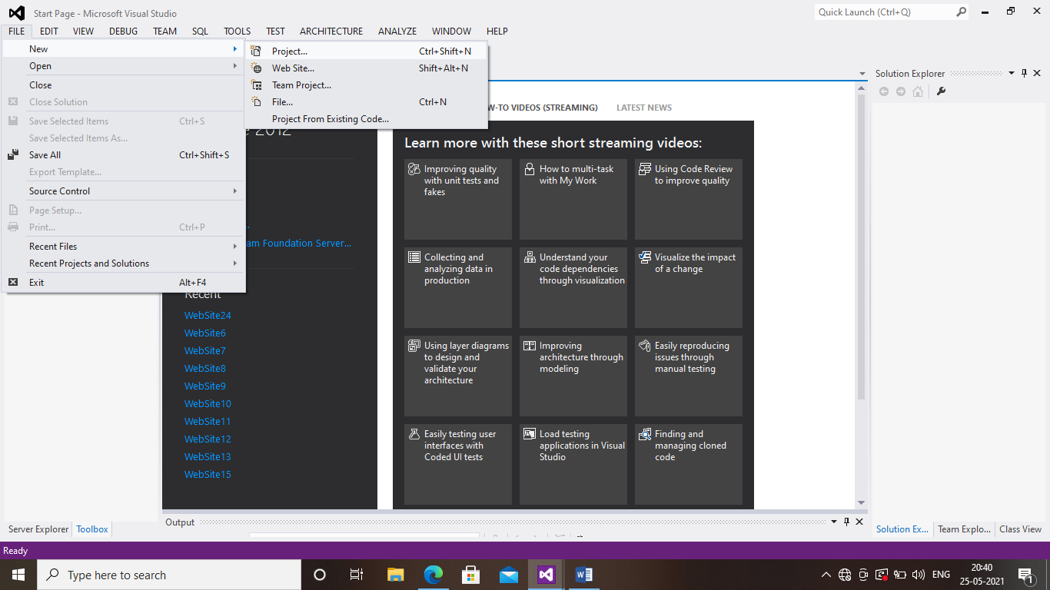

STEP 2:Choose Asp.Net Server Control and change name as Custom control

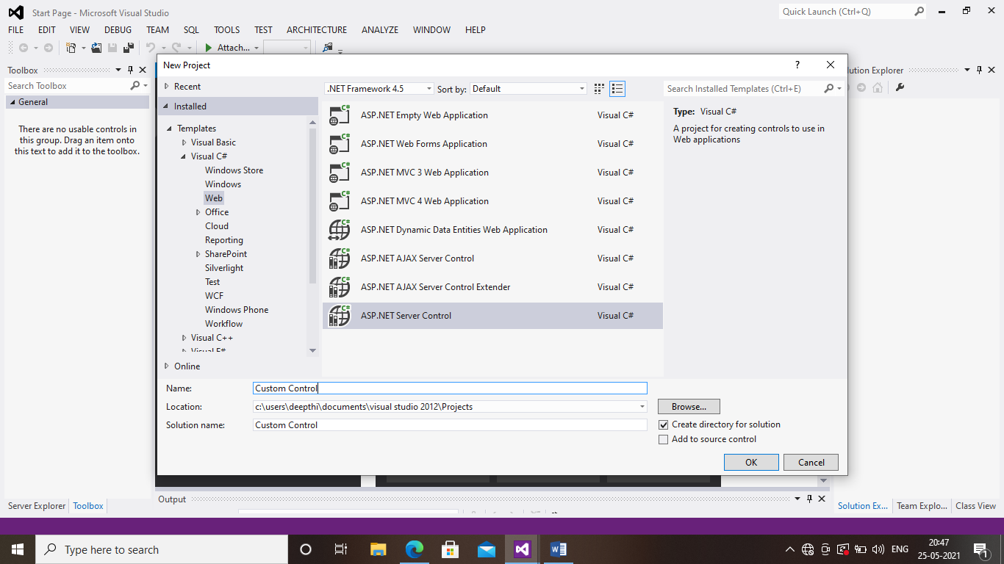

STEP 3:Before moving to the next step right click the custom control and Build the project

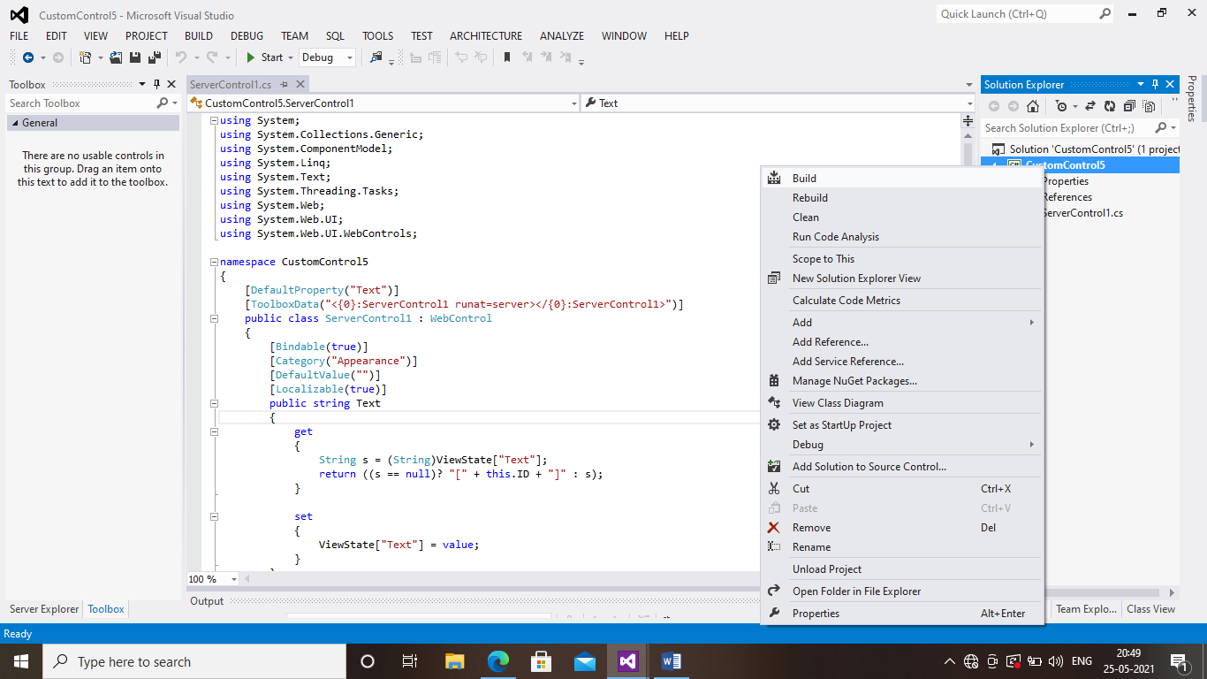

STEP 4:Right click the solution explorer and note it it’s important Click<add<New Web Site

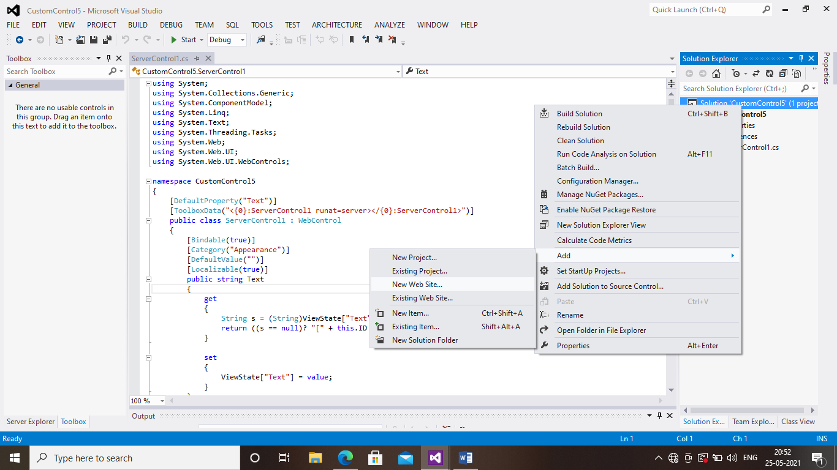

STEP 5: choose Empty Web site

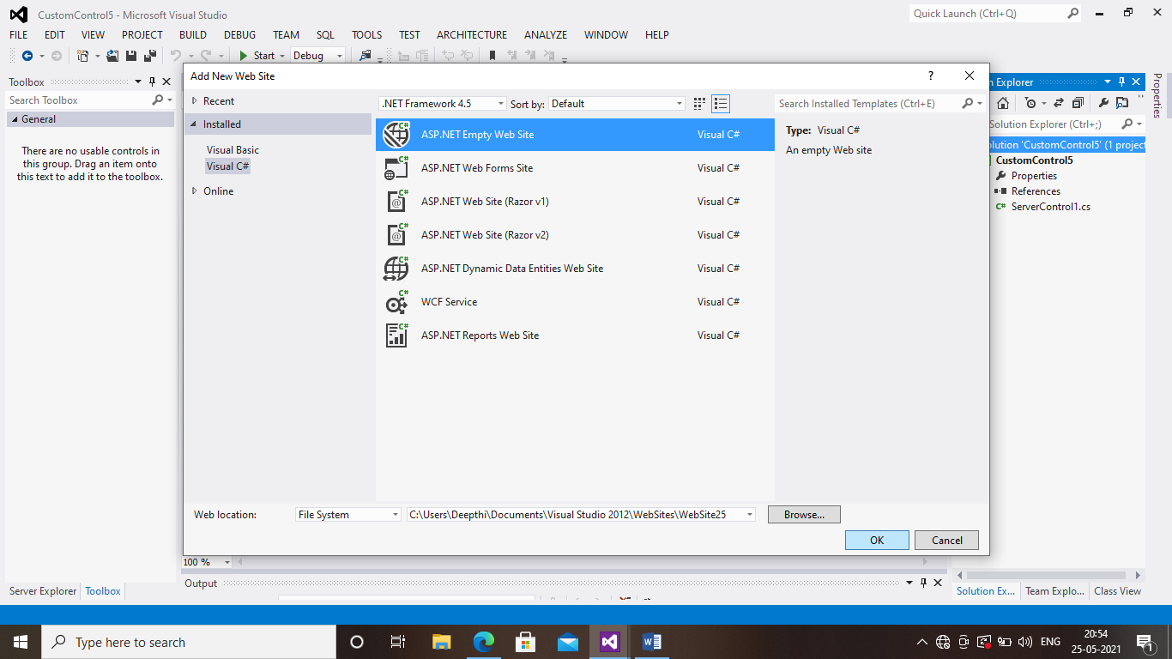

STEP 6:And click Web site and Add<Web Form

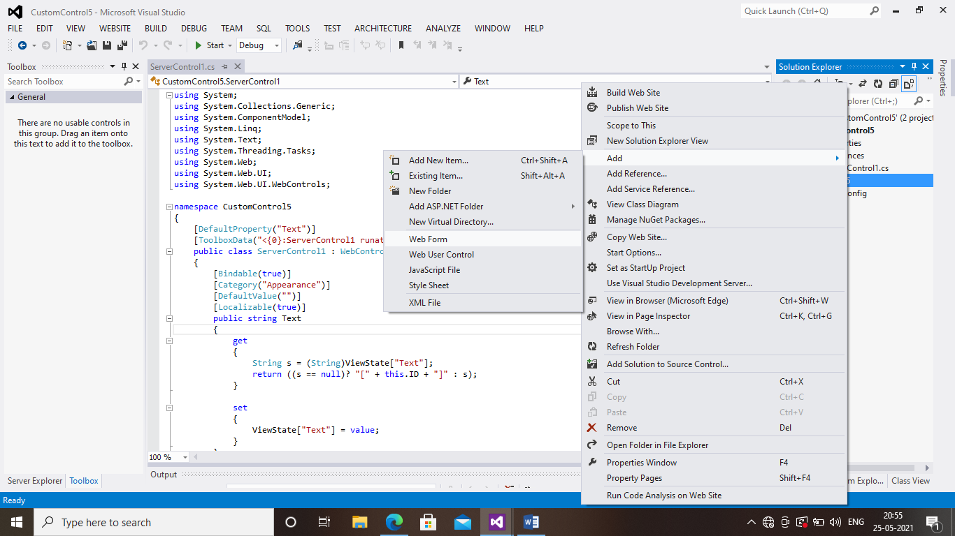

STEP 7:And give the name as MyCustomControl to Web Form

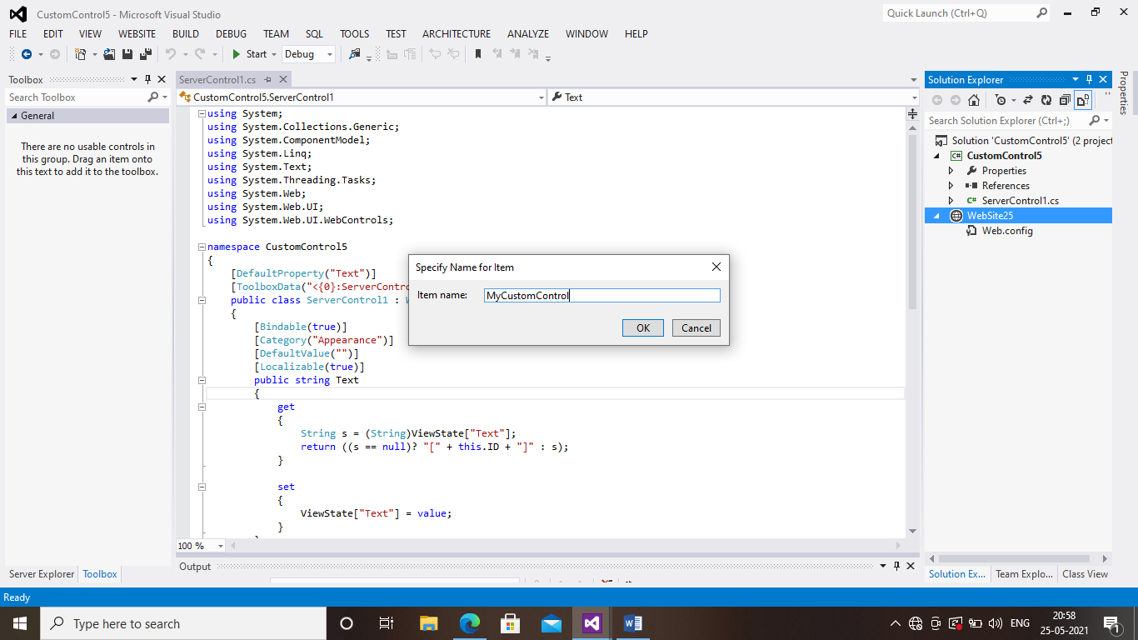

STEP 8:Right click on Web site and add reference and Check the check box as shown below

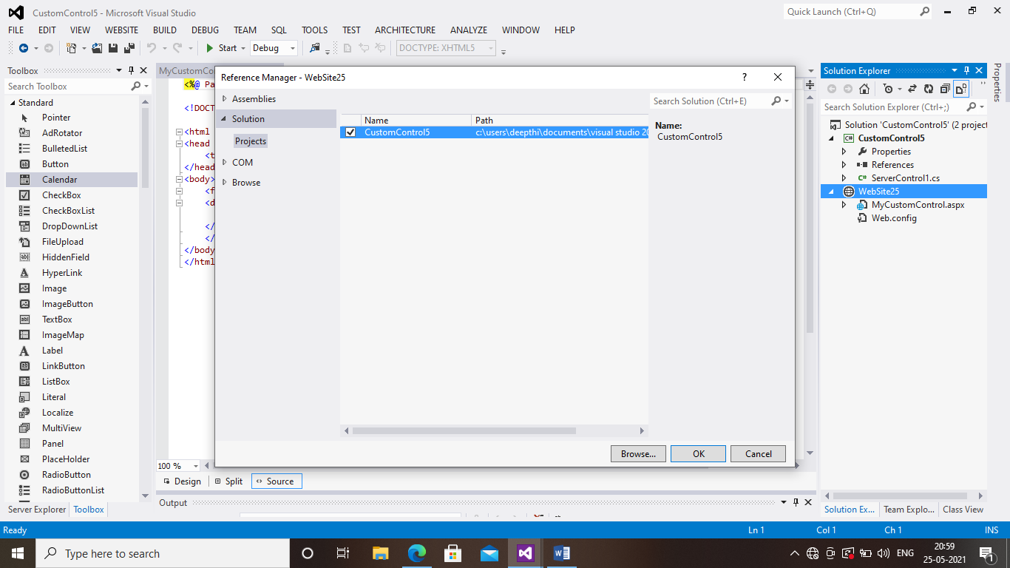

STEP 9:After choosing your project automatically u will get the DLL files as shown in below image

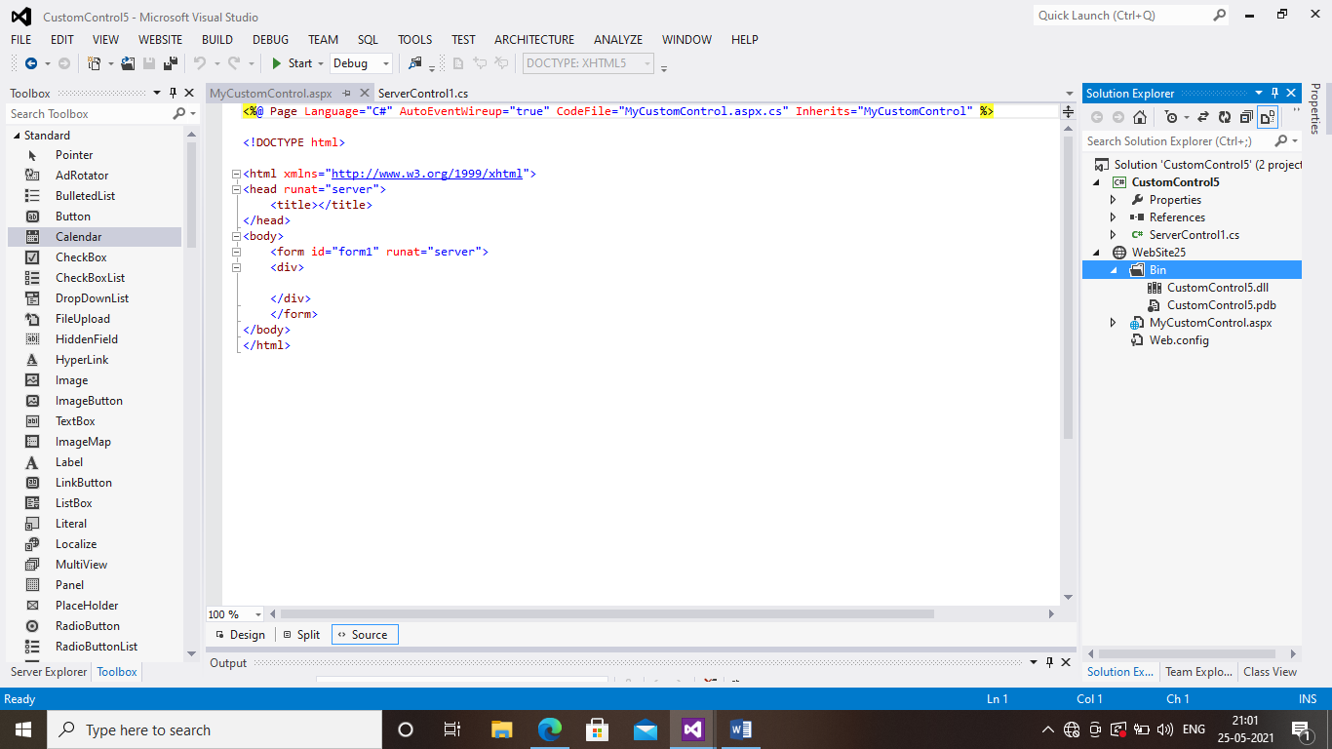

STEP 10:Go to the toolbox choose General tab ,right click on general tan abd Add new tab and name it has CustomControl

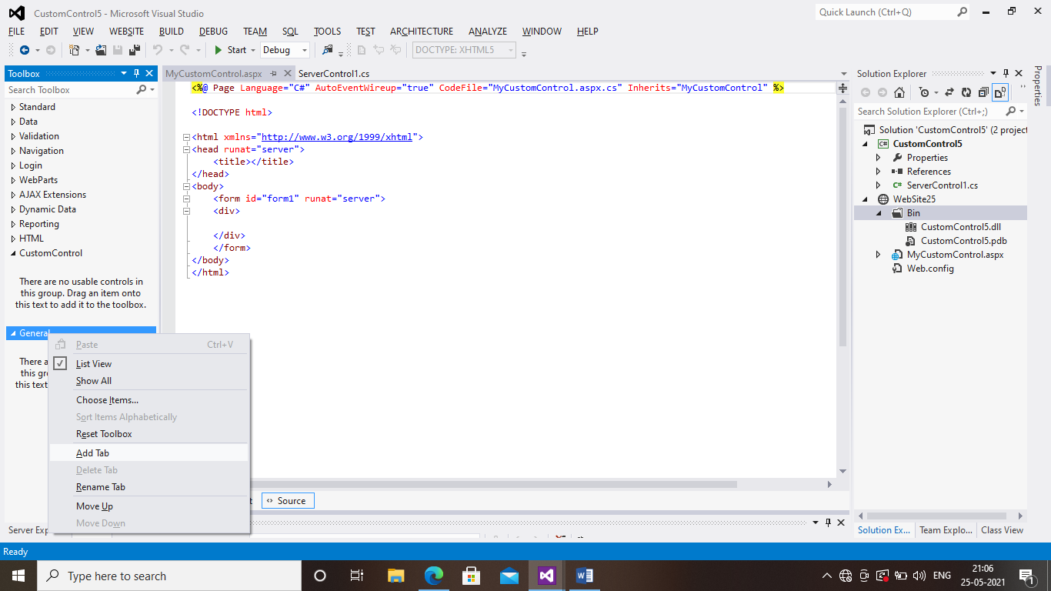

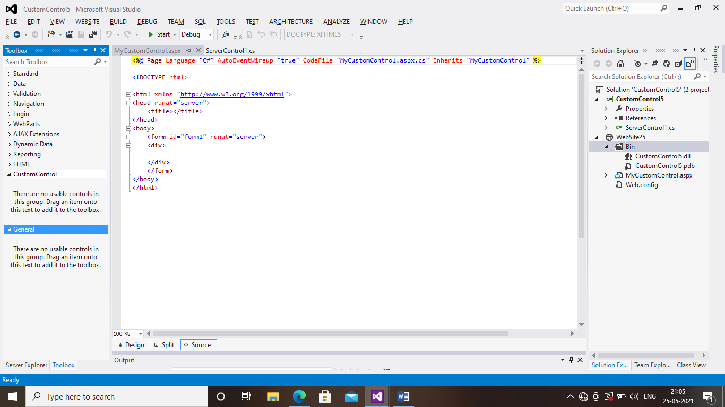

STEP 11: right click on server control and choose open containing folder

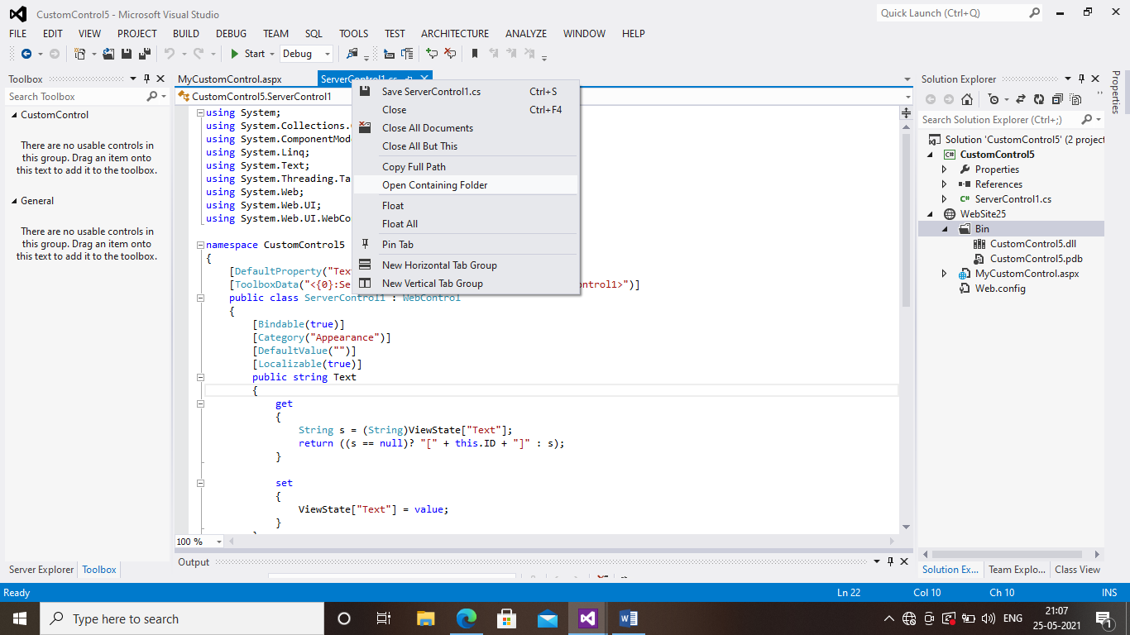

STEP 12:Double click on bin

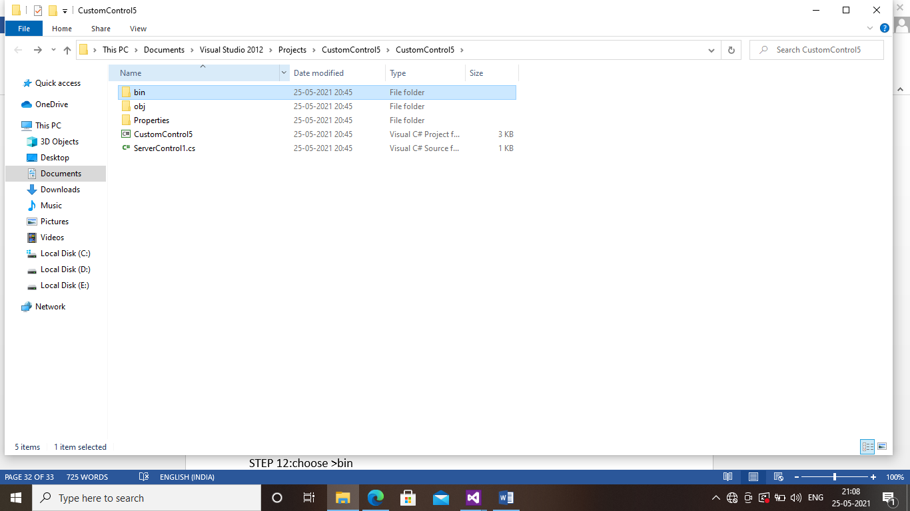

STEP 12:Double click on debug

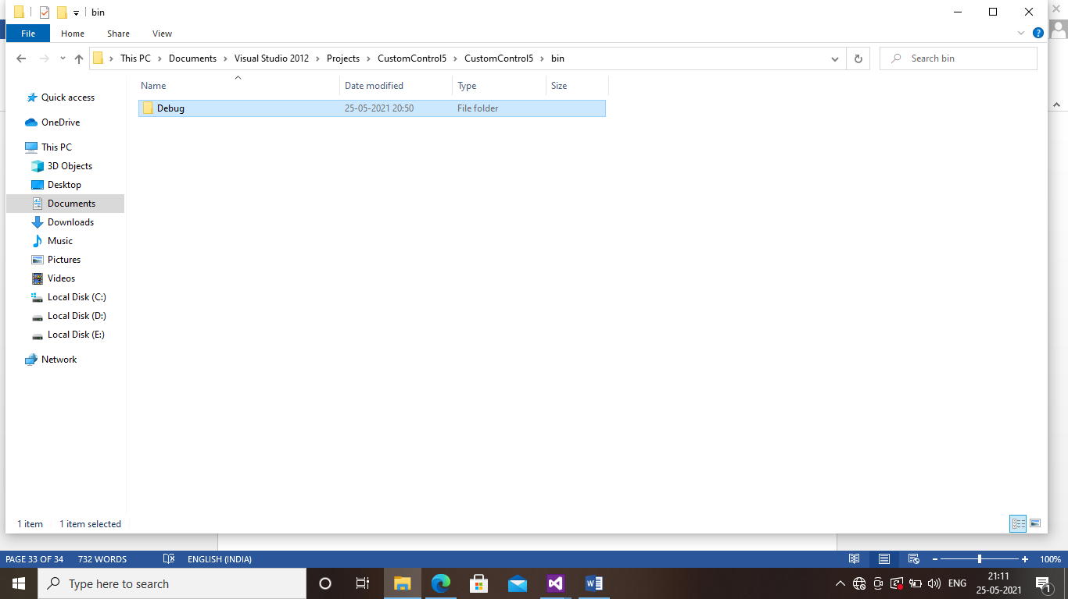

STEP 13:Copy the DLL folder

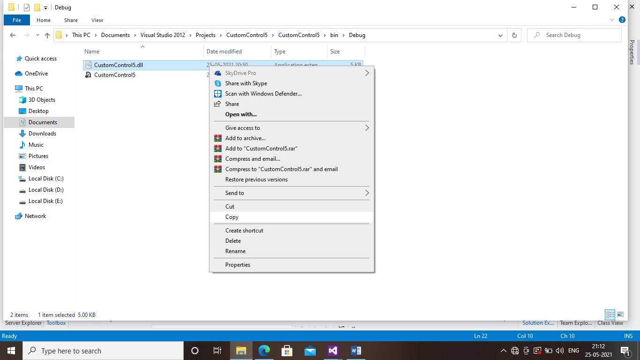

STEP 14:paste the dll file in custom control tab

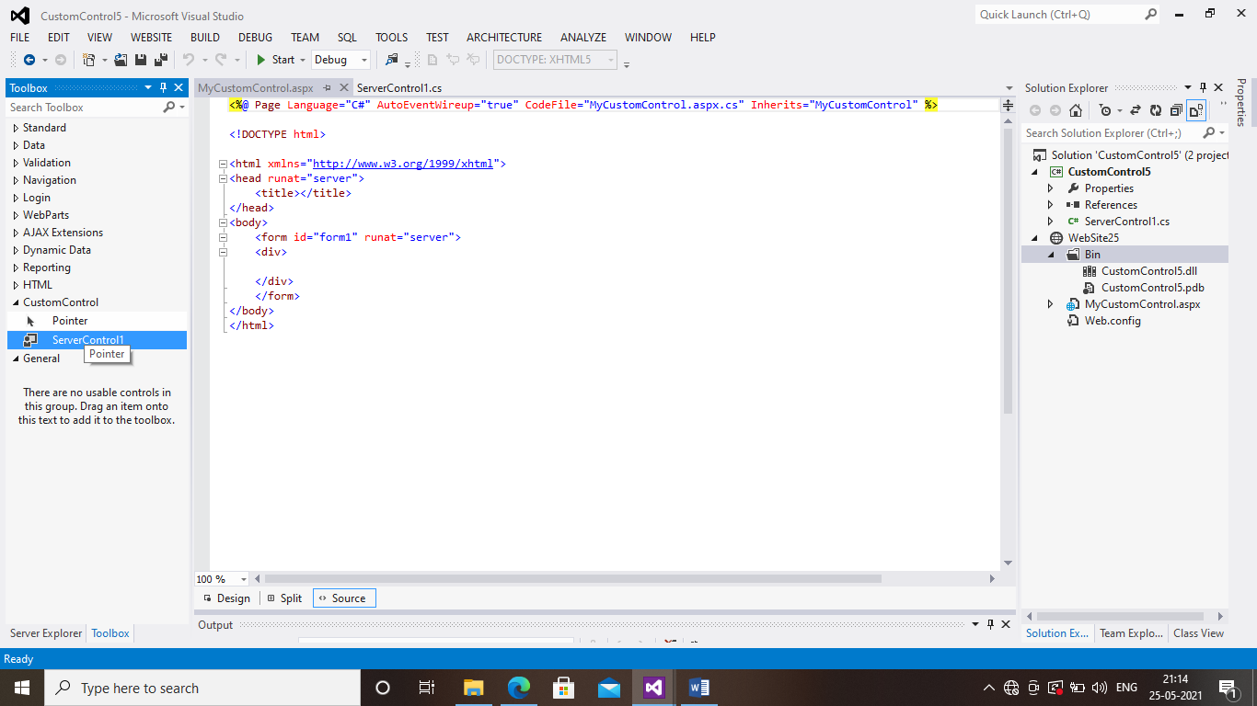

STEP 15:Drag and drop the choosen server control in mycustom control page the line will be displayed which I have highlighted in below page

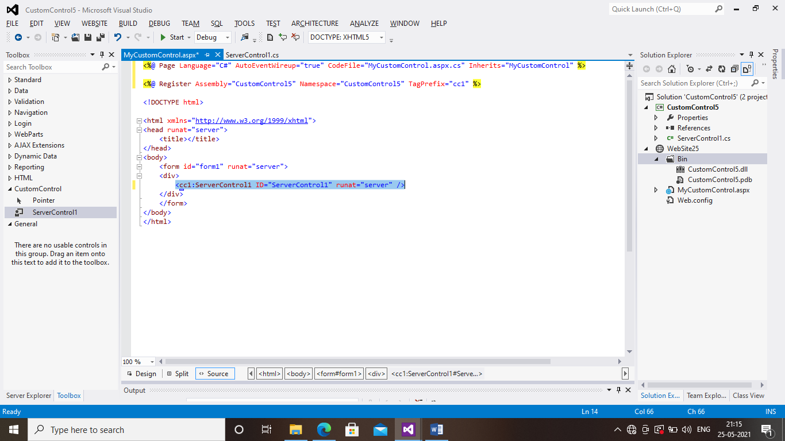

STEP 16:Design the page and the coding will be in source code

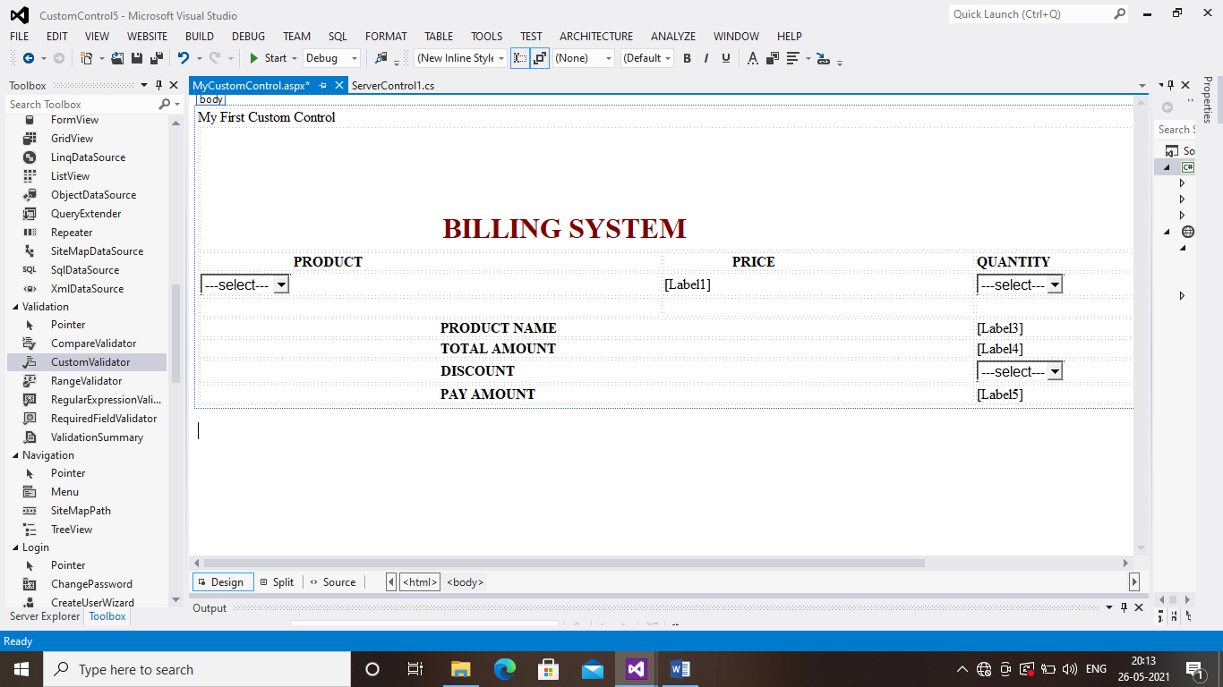

STEP 18:Double click all the three drop down list box and type the coding given to u

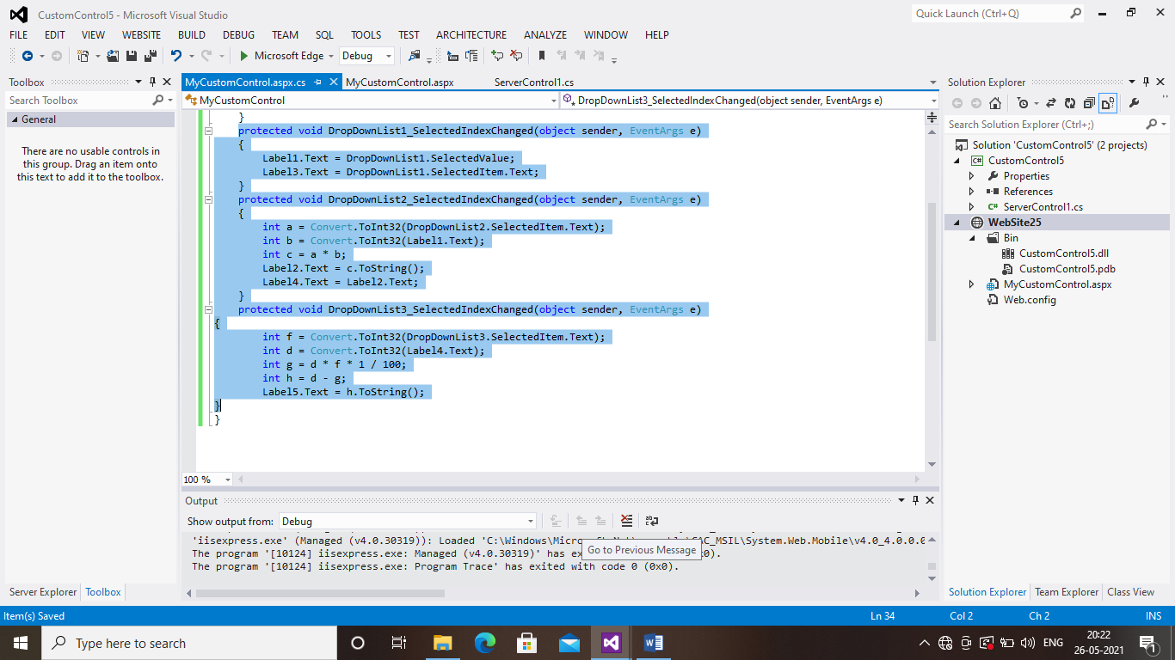

STEP 18:Save and run the project before running the project Right click the website and click set as start up project

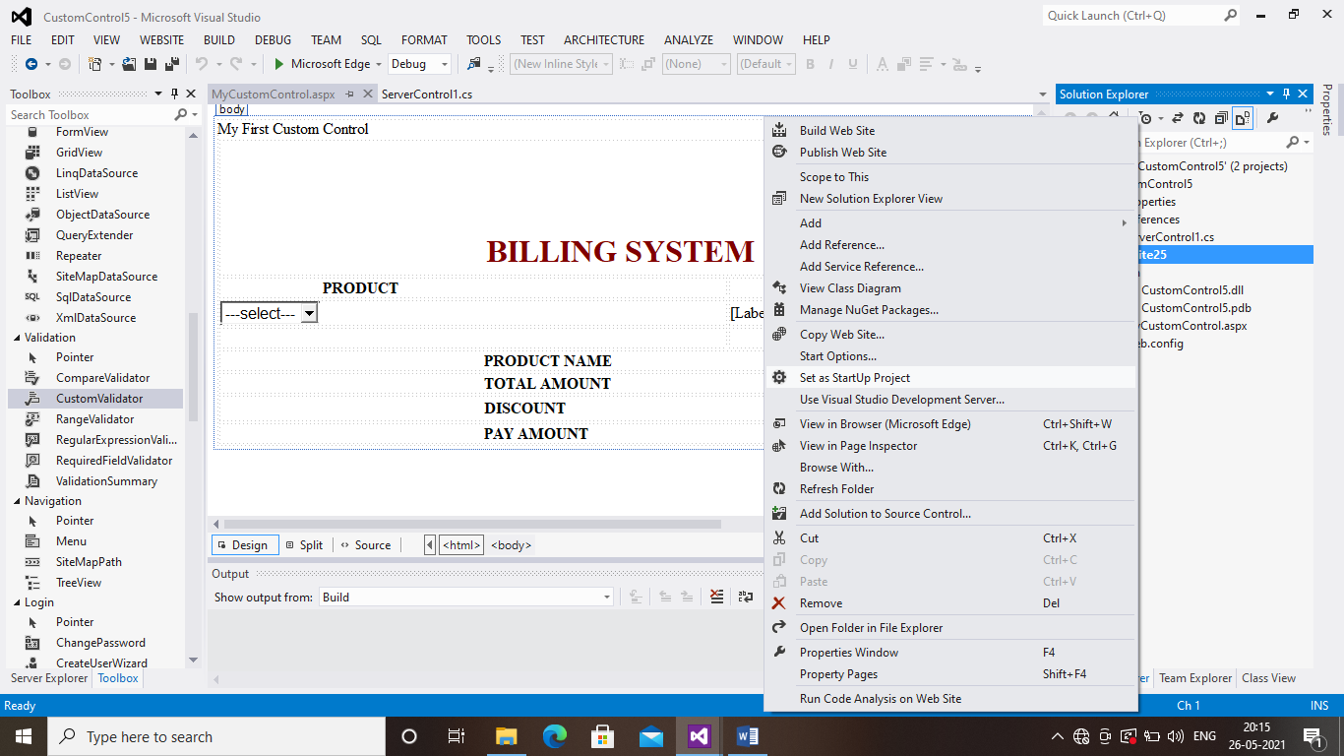

PROGRAM 10:USER CONTROL

STEP 1:Go to file<New<Project

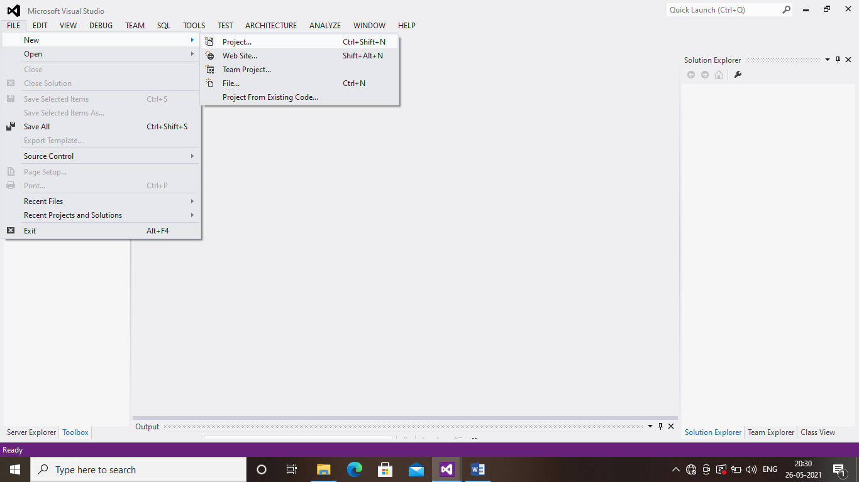

STEP 2:Choose web<Web form application

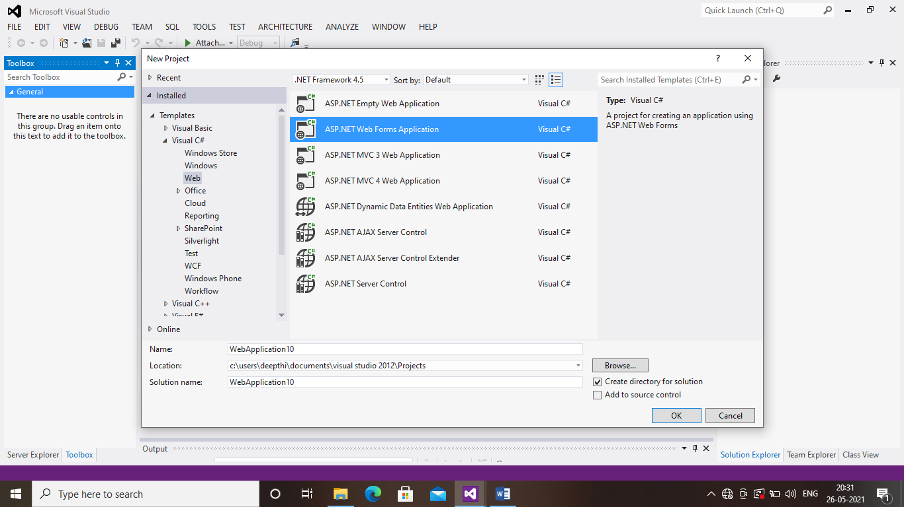

STEP 3:Right click the web azpplication in solution explorer and Add<new Item

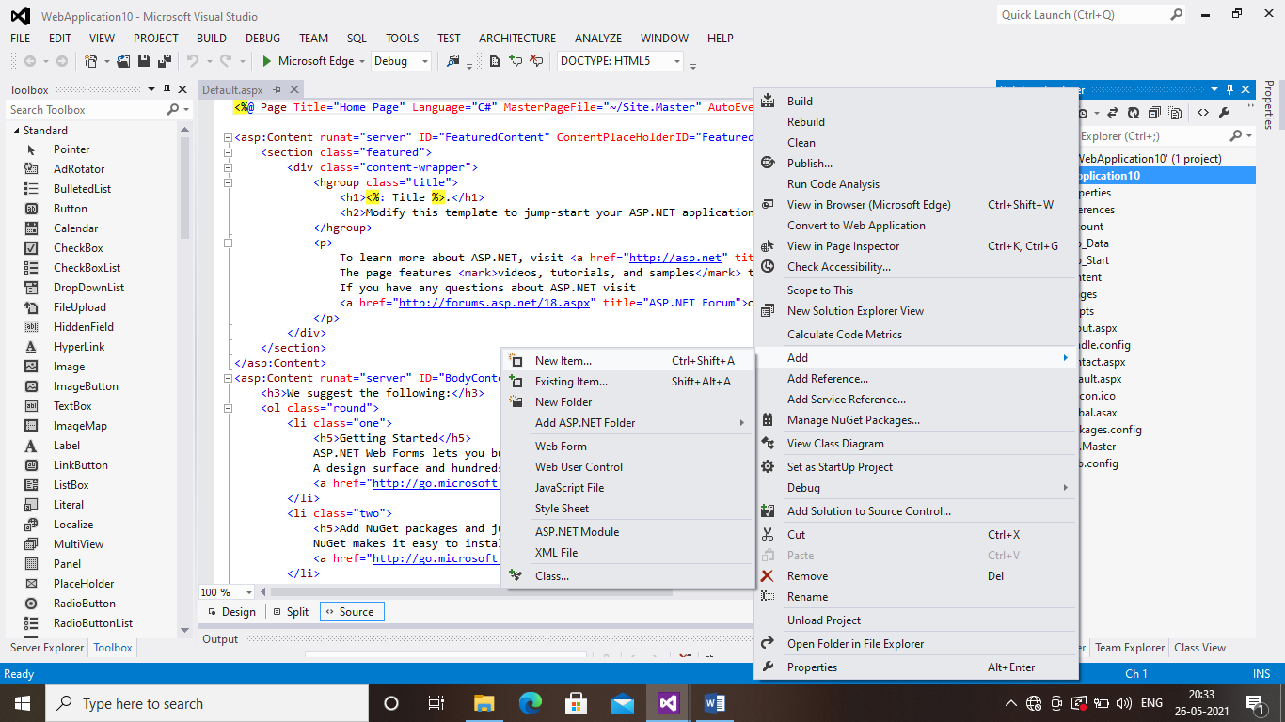

STEP 4:Choose Web User Control

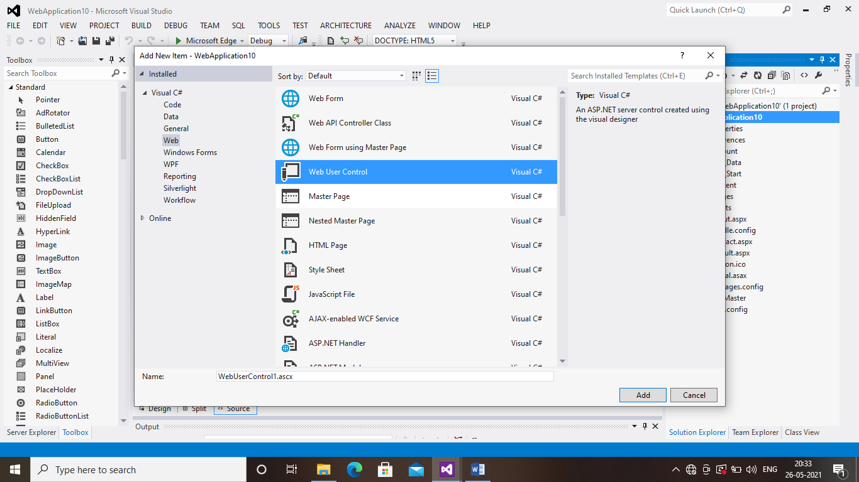

STEP 5:Design the page as show below

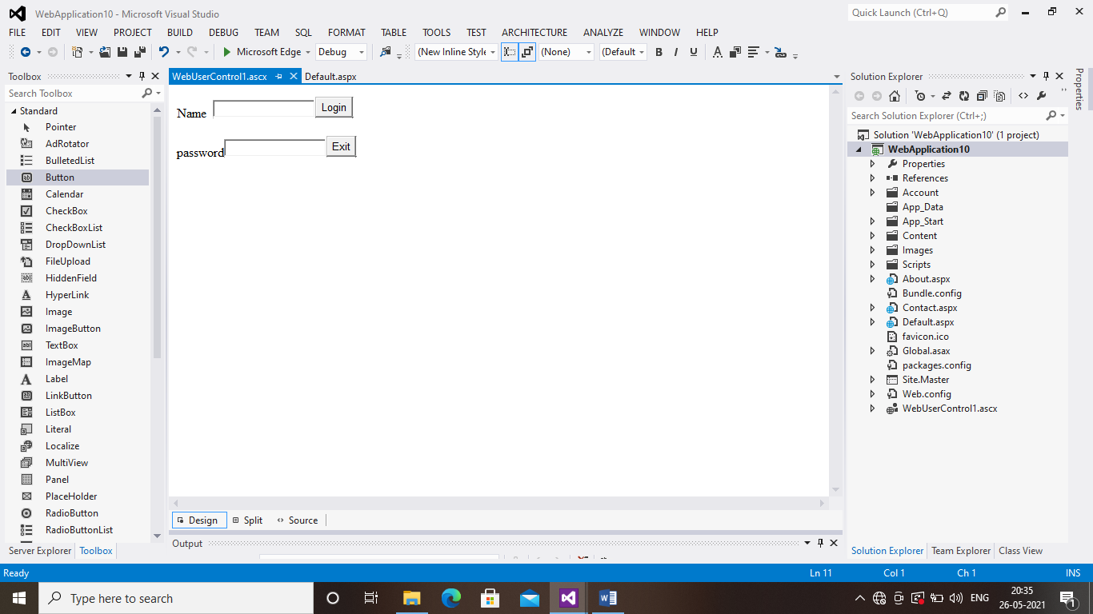

STEP 6:Type the code in default.aspx page which is highlighted in below screenshot

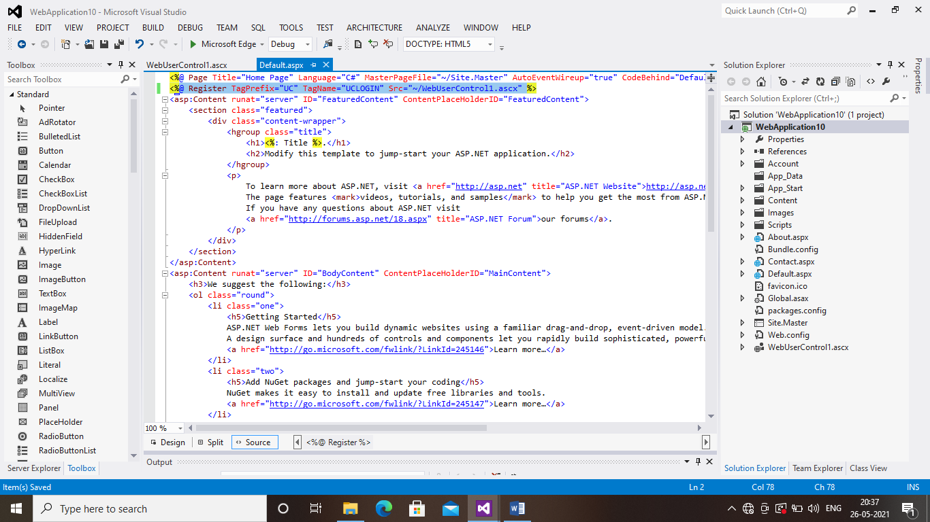

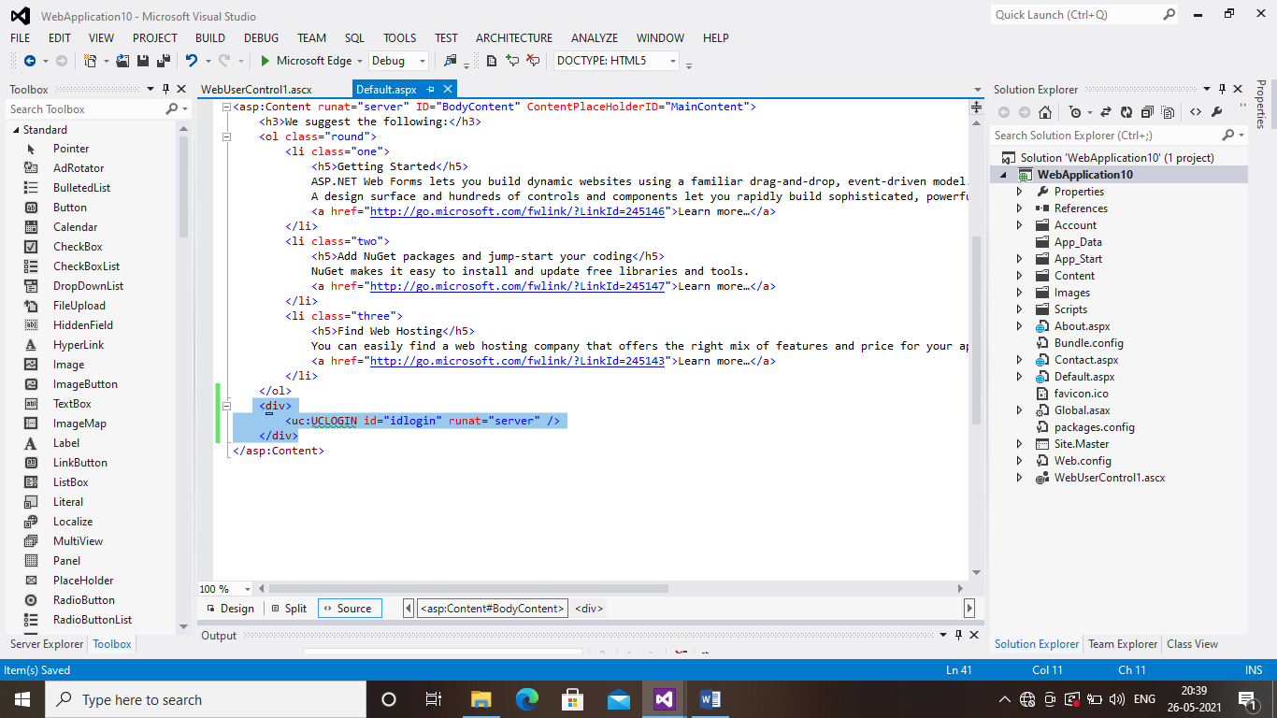

STEP 7:Save and Run the page